**CHAPTER-1 INTRODUCTION**

* 1. **Overview**

The idea of smart parking was put forth to address the issue of parking availability and management in megacities. Due to the increasing number of vehicles on the road and the limited supply of parking spaces, there is no way to avoid vehicle congestion. Driver hostility and environmental pollution would result from this congestion. Finding a spare parking space is nearly impossible during peak hours when the flow density is at its highest, and these conditions may get worse.

The simplest strategy is to give a route with a specific destination instruction inside the parking garage. Smart parking technology shows a visible result of an accessible parking spot as opposed to having the driver drive around aimlessly. The driver scans the line of ascending LED lighting and colour.

Red and yellow are the two primary colours used to denote occupied and free space, respectively. The driver looks up, follows the set of LEDs, and looks at the Yellow LED that is located at the ceiling of each parking space. When a vehicle is detected, This lighting is automatically controlled by sensors, and the results are communicated with the aid of the LED's colour. This gadget not only makes things more accessible but also manages traffic to shorten wait times.

The internet of things was first introduced in 1999. at the self-ID centre, Kevin Ashton used it for the first time. With the advancement of this most recent burning technology, everything in our environment will be able to communicate with one another while requiring less human interaction.

The internet of things is still in its early stages, and there is no established standard architecture. All relevant fields are currently conducting numerous studies and implementations. As a result,

there are no rules or limitations that specify what constitutes the internet of things. Therefore, the definition of an application of the internet of things varies depending on the context.

It can be summed up by saying that objects that are present in the real world or in an environment are wired or wirelessly connected to a network and have sensors or other embedded devices attached to them. These related items are known as smart tools or smart objects. It also includes machines with intelligence and communication, the outside world, & various different things.

Additionally, it includes ways to connect any two machines, including those that connect machines to people and people to machines, or M-M communication. As the technology advances, several standardisation organisations have worked on M-M communication-related projects, including the Open Mobile Alliance (OMA), European Telecommunication Standards Institute (ETSI), Institute of Electrical and Electronic Engineers (IEEE), and 3rd Generation Partnership Project (3GPP) organisation.

The use of transceivers, sensors, actuators, microcontrollers, and other communication devices simplifies daily tasks. One of the key advantages of the internet of things is the ability to track behaviour. Other advantages include improved situational awareness, sensor-driven analytics for decision making, quick response, etc. IOT technology is developing across a range of intelligent application domains, but its limits are still undefined. These include applications for grids, lighting, energy, cities, and health that are all "smart”.

It is currently putting these technologies into practice. Sensing, processing, and connectivity are three broad classifications of this. Sensing, on the other hand, entails determining variables like temperature, pressure, and the speed of moving objects like cars, people, or any other object (accelerometer). And a variety of processors, such as, these can be processed by network processors, MCU/MPU hybrids processors, etc. Additionally, various technologies, including GPS, Wi-Fi, BT/BTLE, RFID, and, are used to connect devices. Majority of people on the planet reside in urban areas. Therefore, the cities are fully occupied.

As more people utilize cars for transportation, there are a lot more cars available for people's convenience. Most of the time is spent by people looking for parking spots to leave their cars

in. Because of the resulting traffic, finding a parking spot for their car becomes a challenging task. Only congested roads in urban areas experience heavy traffic, which causes people to waste time looking for parking spaces in odd places. Our solution uses a Parking space that can be found using a Raspberry Pi-based parking sensor and a pi-camera, which then sends the information to a server where it is stored and later accessed by users.

This makes it easier for the user to check the status and availability of parking spaces prior to leaving on a trip. Here, the challenge is to make the best use of the available resources in order to cut down on search times and city traffic. Some embedded systems, including the Arduino, Raspberry Pi, Tsgate, Tsmote, and others, are used to develop IoT applications. We aim to design a system with lower costs and higher performance. A few existing parking systems use sensors to collect data, but since sensors, like video sensors, are expensive, our goal is to design a system that does so more affordably.

When the first mention of the internet of things in 1999 at the autoID centre, Kevin Ashton used it for the first time. With the advancement of this most recent burning technology, everything in our environment will be able to communicate with one another while requiring less human interaction.

There is currently no established standard architecture for the internet of things because it is only in the beginning stages. As a result, there are no rules or limitations that define what the term "internet of things'' means. As a result, the definition of the internet of things depends on the context and application. It can be summed up by saying that objects that are found in the real world or in an environment are embedded with sensors or other systems and connected to networks using wired or wireless connections. These connected devices are referred to as smart devices or smart objects.

It also includes intelligent machines that communicate with one another, their surroundings, and other objects. It also includes connections between any two machines, as well as between machines and people and vice versa. This exchange is known as M-M communication. Different standardisation organisations, including the Open Mobile Alliance (OMA), European Telecommunication Standards Institute (ETSI), Institute of Electrical and Electronic Engineers (IEEE), and 3rd Generation Partnership Project (3GPP) organisation, have carried out some

M-M communication-related activities as the technology develops. The use of transceivers, sensors, actuators, microcontrollers, and other communication devices simplifies daily tasks.

The ability to track behaviour is one of the internet of things' main benefits. Improved situational awareness, sensor-driven decision analytics, quick control, and responsiveness are additional benefits.

It is now implementing a number of smart applications, including those for smart grids, smart lighting, smart energy, smart cities, smart health, etc. Sensing, processing, and connectivity are three main classifications of this. While detecting includes detecting the speed of moving objects. Additionally, the devices are connected by a number of technologies including Wi-Fi, GPS, BT/BTLE, RFID, and others.

Urban areas are home to the vast majority of people on the planet. Therefore, the cities are fully occupied. There are many vehicles available for people's convenience as more people use vehicles for transportation. The majority of people's valuable time is spent looking for places to park their cars. As a result, it can be challenging for drivers to find parking spaces when there is traffic congestion. The main cause of traffic in urban areas is vehicle congestion, which causes people to waste time looking for parking spaces in unusual ways. Our system is a parking sensor built on a Raspberry Pi that uses a pi-camera to identify open parking spaces and sends that information to a server, where it is stored and accessible to users. This makes it easier for the user to check the status and availability of parking spaces prior to leaving on a trip. Here, the challenge is to make the best use of the available resources in order to cut down on search times and city traffic.

* 1. **LITERATURE SURVEY**

###### [1]

It takes a lot of energy and time to find parking, which produces high costs. In order to effectively manage and enhance resources, smart cities use modern technologies of every kind. Parking lots in cities are a valuable resource that must be managed. The smart parking management system was developed by us to manage parking and assist users in saving time, effort, and money (SPMS). In the context of contemporary life, it has become crucial to improve parking availability searches and decrease traffic jams at parking entrances. Where there is a possibility of parking issues, searching for or reserving available parking online in

advance is a preferable alternative to looking for space at a parking lot. We developed our technology-based smart parking management system to:

* + - Control parking and deal with problems well
    - Make use of technological advancements to further the concept of smart cities.

The suggested system uses a number of technologies to control parking. In addition to other essential services, users can use it to make payments, make reservations, and find parking. More advanced services have been added, such as monitoring parking conditions and receiving notifications and statistics. The system is equipped with sensors and an automatic number plate recognition (ANPR) camera to monitor occupancy and control access. The remaining sections of the essay are structured as follows.

###### [2]

Due to the dramatic increase in the quantity of vehicles while travelling & the inefficient control of the available parking area, the difficulty of navigating urban traffic is getting worse. In order to find parking spaces that are appropriate for a driver's vehicle, as well as to reduce fuel consumption and air pollution, an automated smart parking management system must be developed.

It can take almost 15 minutes to locate a parking space that will suit a driver's needs, which increases fuel use, backed-up traffic, and air pollution. There has been a lot of research done on the designing and creating smart parking systems. An inventory of some characteristics intelligent parking systems:

Parking lot management includes things like real-time route guidance and parking assistance, parking lot reservations, & vehicle occupancy detection. The majority of smart parking systems (SPS) proposed in the literature over the last few years provide answers for the design of parking availability information systems, parking reservation systems, occupancy detection and management of parking lots, real-time navigation within the parking facility, etc. However, the literature pays very little, giving real-time attention to the detection of improper parking and the automatic collection of parking fees. This paper presents an internet-of-things (IoT) based E-parking system that makes use of an integrated component known as a parking metre to address the issues listed below (PM).

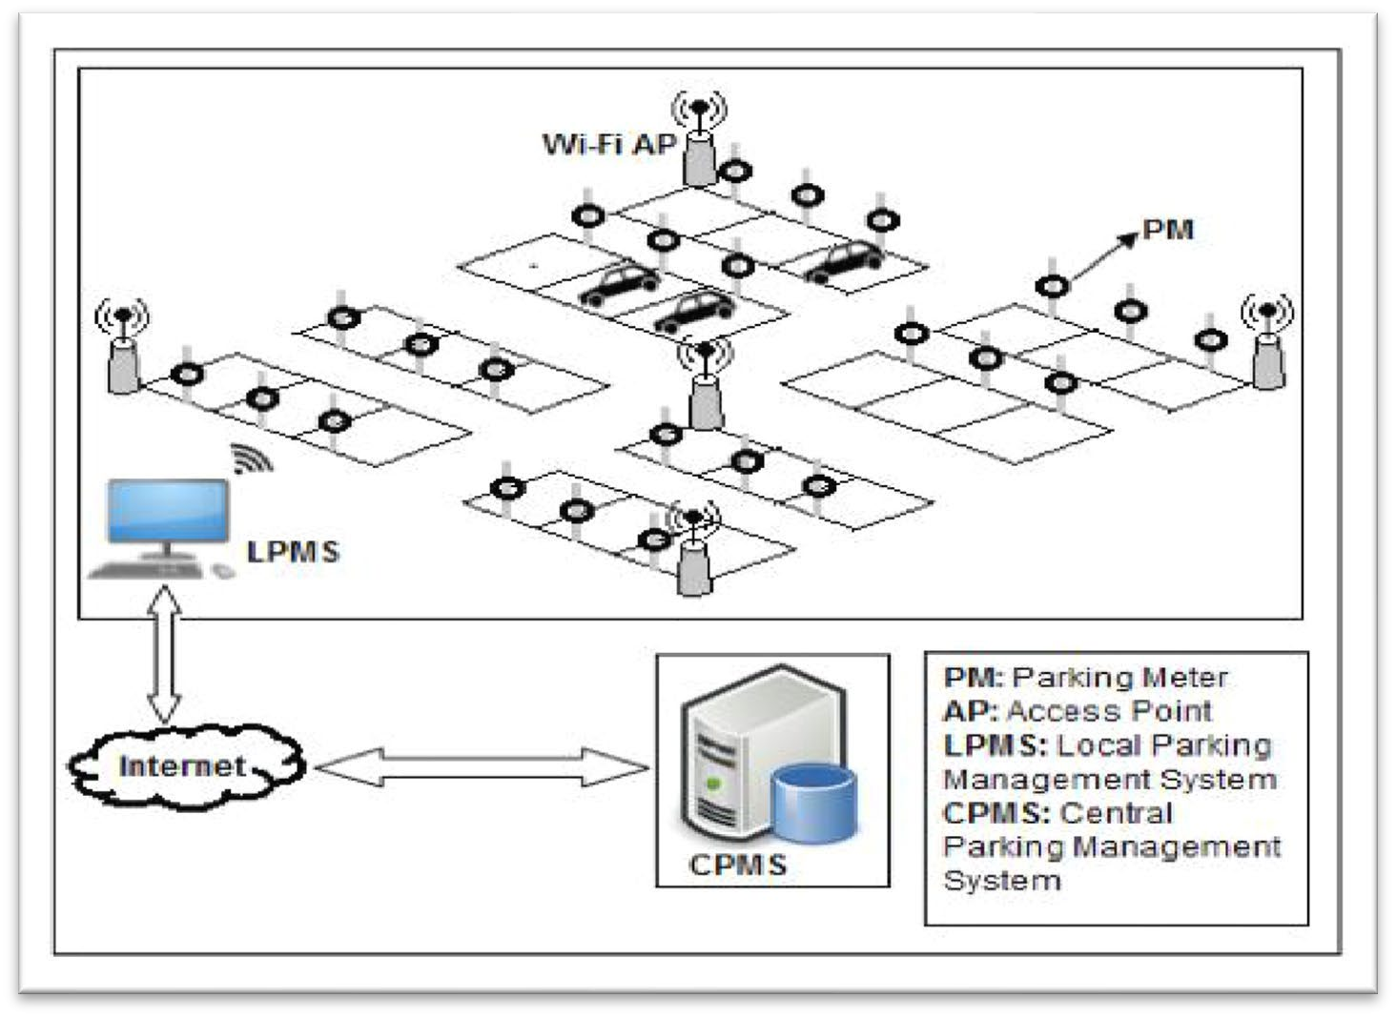Additionally, the E-parking system suggested in this paper known as parking meter (PM) based E-parking, offers a smart parking management programme for the entire city by providing a parking lot and information on the availability of parking facilities reservation system. It also detects improper parking in real-time, predicts how long each vehicle will be parked, and automatically collects parking fees (PM-EP)

**Fig. 1.1 Cloud Based Parking System**

###### [3]

India is becoming more motorised, or more people own private vehicles than use public transportation. The demand for parking spaces to store cars grows along with the percentage of people who own cars.

However, the situation right now is that there aren't enough parking spaces available, or it's possible that people aren't yet aware of the permitted parking spaces in their neighbourhood. This situation causes an unnecessary overcrowding of vehicles on the road and makes it difficult for people to cross the street. We are putting forward an Android application that is multilingual and will help people find parking spaces online as a way to solve the aforementioned issues. Digitally means that the system will assign the user's desired parking space based on his or her convenience and the user's current location.

Digital payments or payments made at vending machines are both acceptable. After the user registers and logs in with his or her account, the system will be able to locate the user's location and display the closest parking area and available parking spaces. If not, the user will be directed to the slot that is the next closest, and so on.

The current system includes both conventional and application-based parking strategy The manual method of parking is used in the traditional method, which requires the user to travel great distances and pay additional fees in order to find a parking space.

Applications that, for example, provide parking spaces for a specific locality comprise an application-based approach. The "Parking Panda" app offers parking spaces to venues like stadiums and sporting events.

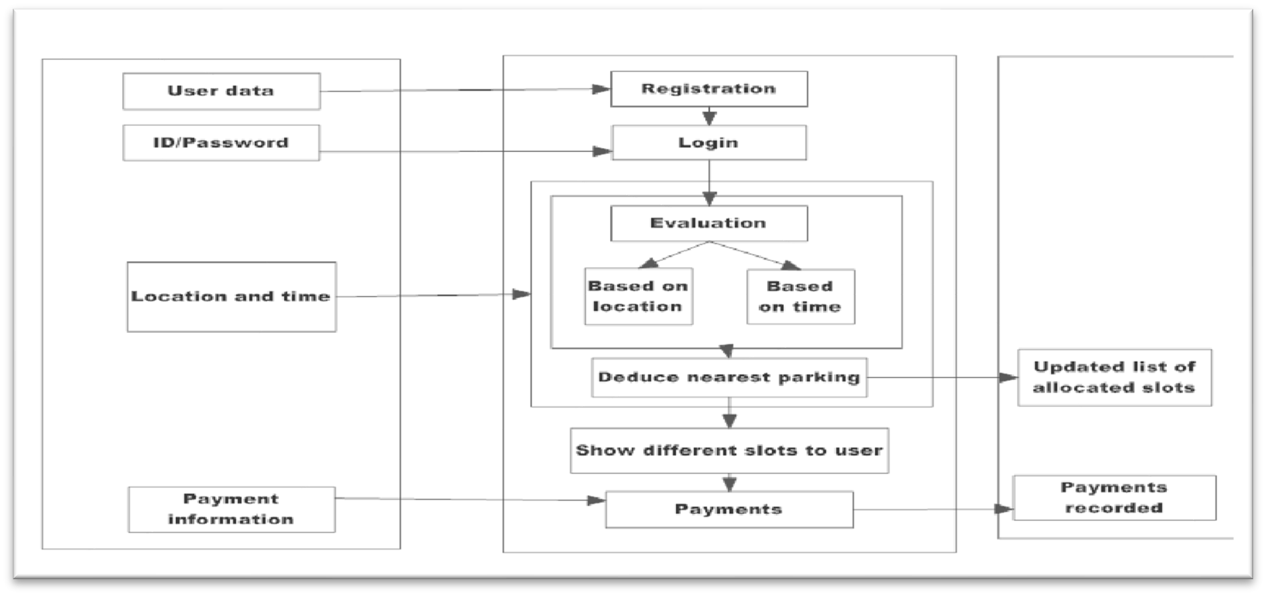

**Fig. 1.2 Flowchart of Methodology**

###### [4]

The key to any nation's success is its transportation system. Many people today have the choice to travel by using their own vehicle. The demand for goods will undoubtedly rise as a result, but "parking" is one of the issues brought on by increased traffic. It has become problematic to park cars in the major metropolises because doing so is a tedious and difficult task.

The implementation of improved and more shrewd parking management mechanisms is the subject of extensive research and development worldwide. Parking requires a central web server, an embedded web server, and a wireless sensor network module. The parking space's

condition is tracked using infrared (IR) sensor nodes in sensor networks, which then send the information to an embedded web server. As a result, user can use the data shown on an LED screen to check for open vehicle slots.

The users are not guided by these systems to the parking lot. Drivers will begin looking for another slot if the one they originally wanted is not available, adding another parking space will make this process time-consuming and worsen traffic congestion.

This paper proposes a reservation-based smart parking system that enables users to reserve parking spaces in advance via a mobile application, thereby reducing traffic congestion. The vehicle parking issues should be resolved effectively and affordably thanks to this application. The user's mobile device needs to have the application installed. Our proposal uses client-server architecture, which is different from the current system in that the client requests that slots be reserved and the server replies with the slots that are open at that moment. The user can select the parking space that best suits his or her needs using our system.

The advantage of this is that it will take the car much less time to find a parking space. The user also has the option of using more sophisticated payment methods like an e-wallet, debit card, or credit card. A penalty will be added for late exit and overusing the slot after the user- specified entry and exit times. On cancellation of a parking space and an early departure, a refund will be issued. The supervisor must keep an eye on the area.

Many of the car parking facilities are becoming overwhelmed by the rise in the number of vehicles on the roads and in parking lots. The present-day wireless sensors or smart parking systems Network Parking requires a central web server, an embedded web server, and a wireless sensor network module. The parking space's condition is tracked using infrared (IR) sensor nodes in sensor networks, which then send the information to an embedded web server.

As a result, the user can use the data shown on an LED screen to check for open vehicle slots. In order to ensure that there are no open spaces, image-capture, devices are used to continuously photograph the parking lot, resulting in high power usage and high maintenance costs. Some systems available on the market use wireless sensor networks and wireless sensors to efficiently locate parking spaces, such as smart parking services. It is not practical to add extra hardware to the car in order to use this system, though.

Parking spots can be extremely hard to find in a crowded city. People frequently find that a parking lot is full and that there are no open spots when they arrive. Then they have to drive around in their car once more to find a parking space.

###### [5]

New technologies are currently revolutionising the parking sector, enabling cities to significantly reduce congestion levels. Sensor networks that detect vehicle occupancy give smart parking systems their fundamental intelligence. It is now possible to find available parking spaces in real-time and help drivers get where they need to go with the help of smart parking technology.

A variety of vehicle detectors have been used to collect parking information. The most popular kinds of vehicle detectors are inductive loops, acoustic sensors, infrared sensors, and ultrasonic sensors. Information collection in the field of vehicle parking has been proposed using a system utilising video camera sensor technologies. However, inclement weather and night-time operation can damage a video camera sensor.

It is also expensive and generates a large amount of data, which can be difficult to transmit over a wireless network. The most popular technique is using wireless area networks and magneto-resistive-based detection systems, networks because of their high accuracy. The potential for electromagnetic interference, which lowers accuracy, and the need for constant data collection, which depletes batteries, are just a few of the issues that this type of sensor has. It has been suggested that a parking sensor system would improve the accuracy of vehicle detection and lengthen battery life.

While energy efficiency has been optimised using power management techniques, a two-fold sensing approach yields high occupancy monitoring accuracy. There are several Signal Strength Indicator (RSSI) techniques that are dark and measurement-based.

The wireless sensors, which are either stuck to the surface of every parking lot or buried in the pavement, are still bothersome. Existing sensors, like Parking lot-specific ground-based sensors can cost up to $200. Because many sensor units are needed to cover the entire parking lot, smart parking technology that uses wireless sensors for outdoor parking is expensive. Despite significant advancements in parking occupancy monitoring systems, the field of smart parking payment research is still in its infancy.

However, there are companies working on patents for parking payment systems. The first technique involves using a camera or an RFID transceiver to find and identify vehicles. A disadvantage of this solution is how difficult and expensive it is to implement when a detection device is placed in each parking lot. When only an RFID transceiver is used for vehicle detection and identification, electromagnetic interference may also reduce the system's accuracy. Furthermore, even though data on empty parking lots is unavailable, this system is designed to detect a vehicle as it pulls into a space and demands payment. When watching the parking of vehicles, it has been suggested to use two cameras to record the entrance and exit of a vehicle.

A method and system for compiling and displaying information on parking spaces is also covered in. The user puts the ID into a parking meter or a smartphone app on his smartphone and makes the parking payment when he parks in a spot identified by an individual ID.

After processing the data, the database uses the parking spaces ID to change the status from unpaid to paid. How many parking spaces are occupied is determined using these details. In this paper, we suggest a smart sensor system for monitoring and paying for outdoor parking without requiring user or driver input. To be deployed, it won't be necessary to upgrade the components in every parking lot. The sensor has advantages for reliable payment and detection, lower costs due to an easier installation process and system design, and longer battery life due to the system's reduced power consumption.

* 1. **Need Analysis**

The advanced technology of a smart parking system is its most significant advantage. In order to guarantee successful results, it adheres to the most recent technologies and ideas. Smart parking is very simple to oversee and manage in terms of both design and implementation. Because of its well-organized structure, staff members can manage this system with ease.

Both the Cloud and the Internet of Things computing have significantly evolved. Each technology has benefits of its own, but their integration is anticipated to have a number of additional advantages. One the one hand, by utilising the boundless potential and resources of the Cloud, IoT can overcome its technological constraints, such as those pertaining to storage, processing, and energy. But by utilising IoT, the cloud can also broaden the scope of its application to deal with real-world entities in a more distributed and dynamic manner.

The Cloud essentially acts as a middleman between things and applications, disguising all the complexity and functionalities needed for an application to function. The Internet of Things and cloud computing were combined for the following reasons. Capacity for storage: The Internet of Things (IoT) is a network of numerous information sources (things) that collectively produce vast quantities of unstructured or semi-structured data.

Massive amounts of data must be gathered, accessed, processed, visualised, and shared in order to support IoT. The cloud offers unlimited, affordable, It is the best and most economical option due to its on-demand storage capability, & way to manage the data derived from IoT. Through common APIs, users can access and visualise data stored in the cloud from anywhere. Processing speed: The IoT devices currently in use have a processing speed.

Information obtained from various more sensors are sent to powerful nodes for processing and aggregation. The use of the Cloud's limitless processing power and on-demand model can meet the computation requirements of the Internet of Things. IoT systems could process data in real- time with the aid of cloud computing, enabling highly responsive applications. x Resources for communication.

The core purpose of the Internet of Things is to enable interoperability between IP-enabled devices using a specific set of hardware. Cloud computing enables the connection, tracking, and management of devices over the internet from any location. by utilising integrated applications IoT systems could remotely manage and monitor objects in real-time. Scalability: The cloud provides an IoT strategy that is scalable. It permits the dynamic growth or decrease of resources. There could be a plethora of "things" added to, removed within the system if integrating the cloud was made possible. The demands of objects and applications are taken into account when allocating resources in the cloud.

Accessibility: With cloud integration, resource accessibility at any time and from any location is made very simple. Many cloud service providers guarantee 5-9 availability. Applications run continuously in the cloud, and users get ongoing services. Interoperability: A variety of different device types are used in the Internet of Things. Compatibility problems may arise as a result of the different hardware or software configurations of these devices.

In an IoT environment, ensuring interoperability between these devices becomes very challenging. Because it provides a common platform for connecting and communicating between different devices, the cloud aids in solving this issue. Data sharing and exchange are permitted between devices in a format that works for them.

There are several angles to consider the problem of parking management, including the volume of traffic on the roads, according to recent studies in big cities. Drivers have troublesome issues when attempting to put their vehicles in parking spaces since it is difficult locating a parking spot.

Drivers wasting time & effort looking for parking spaces and ultimately parking their cars on the street, the parking lot becomes even more crowded. In the worst case scenario, it becomes impossible for people to find a parking space, especially during busy times and the holiday season. Congestion and parking in large cities are two of the most significant issues.

As a result, managing the garage through the internet of things is effective when automated parking system management is used. In order to assist users in finding available parking spaces, smart parking is a technological solution that makes use of sensors and information technology. Some of the most well-liked types of data routing, intelligent payment, and other smart parking systems are all computerised parking lots. For these classes, parking availability must be made known. When a user registers with the system, a special identification number is generated for him.

When the user makes a reservation, the system has the reservation information. The system building is composed of three levels: the lowest level deals with sensing functions; the middle level creates data transmission; and the upper level manages information storage and processing as well as user interfaces.

The current environment exhibits both an excess of cars and a difficulty managing them in the right order. As population growth is accompanied by higher utilisation rates, keeping up with the population becomes more challenging. Anywhere in the world, finding a place to park our car is a constant struggle.

It becomes challenging to find a spot when parking in shopping centres, multistorey IT structures centres, plus parking lots with a large number of parked vehicles. On side streets & interior lanes, this task seems simple.

* 1. **AIM**

Design and Implementation of Smart Parking System

* 1. **Objective of Smart Parking**

Utilizing low-cost sensors, real-time data, and applications that track available and unavailable parking spaces are all part of smart parking. To reduce the manually consuming time looking to find the best parking level, location, or even lot, the procedure will be automatic. Some solutions will offer a comprehensive selection of services, such as online payments, reminders when parking permits are about to expire, and even the ability to search for specific vehicles in very large parking lots. A parking solution can benefit both the lot's user and proprietor.

* **Improved parking** – Users save time, money, and effort by locating the best parking spot that is open. The parking lot quickly fills up, allowing businesses to use the available space efficiently.
* **Reduced traffic**: Traffic flow increases as fewer vehicles are required to search for available parking spaces.
* **Pollution reduction** - Locating parking burns almost a million barrels of oil every day. The amount of daily car emissions will be reduced thanks to an ideal parking solution, which will also result in a significant reduction in travel time and eventually, global environmental pollution.
* **Increased Security** - Security guards and parking lot staff have access to current lot information that can help stop parking infractions and strange behaviour. Relevant information can be gathered by cameras that can read licence plates. Furthermore, checks on the street can get more relevant film if there is less street traffic. Additionally, fewer people hunting for parking spots on the streets can lessen accidents as a resultof parking's diversion.
* **Management costs -** Lower costs and higher automation reduce labour costs and resource exhaustion.
* **Improved User Experience** - Every element of the user experience will be included in a single activity with a smart parking system. The steps in the process of getting to the

destination include paying the driver, conducting location searches, identifying specific locations, and receiving time alerts.

* 1. **Problem Formulation**

According to recent studies in large cities, there are several ways to look at the issue of parking management, including the amount of traffic on the roads. Due to the difficulty in finding a parking space, this causes bothersome problems for the drivers when trying to park their cars.

The parking lot becomes even more crowded as a result of drivers spending time and energy looking for parking spaces but ultimately leaving their cars parked on the street. In the worst case, finding a parking spot is impossible, particularly during rush hour, busy times and the holiday season.

* 1. **Expected Deliverables**

The main important benefit of a smart parking system is its advanced technology. In order to guarantee successful results, it adheres to the most recent technology and ideas. Smart parking is simple to oversee and manage in terms of both design and implementation. Because of its well-organized structure, staff members can manage this system with ease.

This system can provide users with parking information, but it is unable to indicate which parking spaces are available and occupied. As a result, the system is unable to handle the problem intelligently. Corporate offices, movie theatres, shopping centres, IT hubs, and other places can install this system. In many public locations, the system only displays the availability and is unable to display the precise slot and route to the slot that is open. Therefore, it is necessary to deftly locate the route to the open space.

* 1. **Novelty of Work**

This type of project can help various ways like:

* It will help the consumer to find the empty slot easily.
* It reduces the time to search for the empty slot thereby preventing aimless search of free slots.
* It even helps in reducing fuel consumption.
* This system provides high security
* It reduces labour as the whole system is automated.
* It will be useful in parking areas where capacity is more than 1000 like cinemas, airports, shopping malls, IT Hubs, Offices etc.

**CHAPTER-2**

**THEORY, STANDARDS AND CONSTRAINTS**

* 1. **Overview**

To address this issue, a computerized parking system has been developed. People typically roam around parking areas looking for an appropriate spot to park their cars. It is necessary to use assistive technology, which could grant registered users of mobile devices and their applications access to parking data. Users will be allowed to access the service by signing up, & while booking, the destination & anticipated time of arrival are calculated and the booking details will be sent to the user. The core purpose of the Internet of Things is to enable interoperability between IP-enabled devices using a specific set of hardware. Cloud computing enables the connection, tracking, and management of devices over the internet from any location. by utilising integrated applications IoT systems could remotely manage and monitor objects in real-time. Scalability: The cloud provides an IoT strategy that is scalable. It permits the dynamic growth or decrease of resources. There could be a plethora of "things" added to, removed within the system if integrating the cloud was made possible. The demands of objects and applications are taken into account when allocating resources in the cloud.

* 1. **Working Principle**

Smart parking uses an Internet of Things based system that will be sending the information to open & occupied parking lots through web and smartphone applications. Each parking space has sensors and microcontrollers that are part of the Internet of Things (IoT) network. With the help of IR sensors and the Internet of Things, we developed an enclosed smart parking project (SPMS) where available parking spaces are found and will be shown in a mobile application and send a real-time update on free slots of all parking spaces to the users and they can select the best one according to them. A method and system for compiling and displaying information on parking spaces is also covered in. The user puts the ID into a parking meter or a smartphone app on his smartphone and makes the parking payment when he parks in a spot identified by an individual ID.

After processing the data, the database uses the parking spaces ID to change the status from unpaid to paid. How many parking spaces are occupied is determined using these details. In this paper, we suggest a smart sensor system for monitoring and paying for outdoor parking without requiring user or driver input. To be deployed, it won't be necessary to upgrade the components in every parking lot. The sensor has advantages for reliable payment and detection, lower costs due to an easier installation process and system design, and longer battery life due to the system's reduced power consumption. The wireless sensors, which are either stuck to the surface of every parking lot or buried in the pavement, are still bothersome. Existing sensors, like Parking lot-specific ground-based sensors can cost up to $200. Because many sensor units are needed to cover the entire parking lot, smart parking technology that uses wireless sensors for outdoor parking is expensive. Despite significant advancements in parking occupancy monitoring systems, the field of smart parking payment research is still in its infancy.

|  |  |  |
| --- | --- | --- |
| **1** | **Collection** | Parking sensors are necessary for the collection of real-time parking. To determine whether a parking space is vacant or not, the parking systems use sensors like infrared and ultrasonic sensors. Also, an ESP8266 Wi-Fi chip consists of the TCP / IP protocol that licenses any microcontroller to contact a Wi-Fi network. |
| **2** | **Processing** | The processing unit interferes between the sensors and the cloud. It includes an on-chip processor called an Arduino. The esp8266 chip is used to transmit data collected from various sensors to the processing unit, which is wirelessly connected to all of the sensors. |
| **3** | **Deployment** | Communications strategies are covered. Message Queue Telemetry Transport Protocol (MQTT) is a publish- subscribe-based messaging protocol that sits on top of the TCP/IP protocol. |

|  |  |  |
| --- | --- | --- |
| **4** | **Services** | Once they are done with data storage and information monitoring, it will be made available to users. |
| **5** | **Connection** | The Internet of Things layer, which manages the shared server's database of parked cars, has my interest. information on the websites, profiles, and parking spots that are open to users, etc. exists as cloud storage. It records a copy of the cloud-stored data and keeps track of every user who has logged in. |
| **6** | **Mobile application** | It serves as the system's and people's interface. |

**Table 2.1 Working of Project**

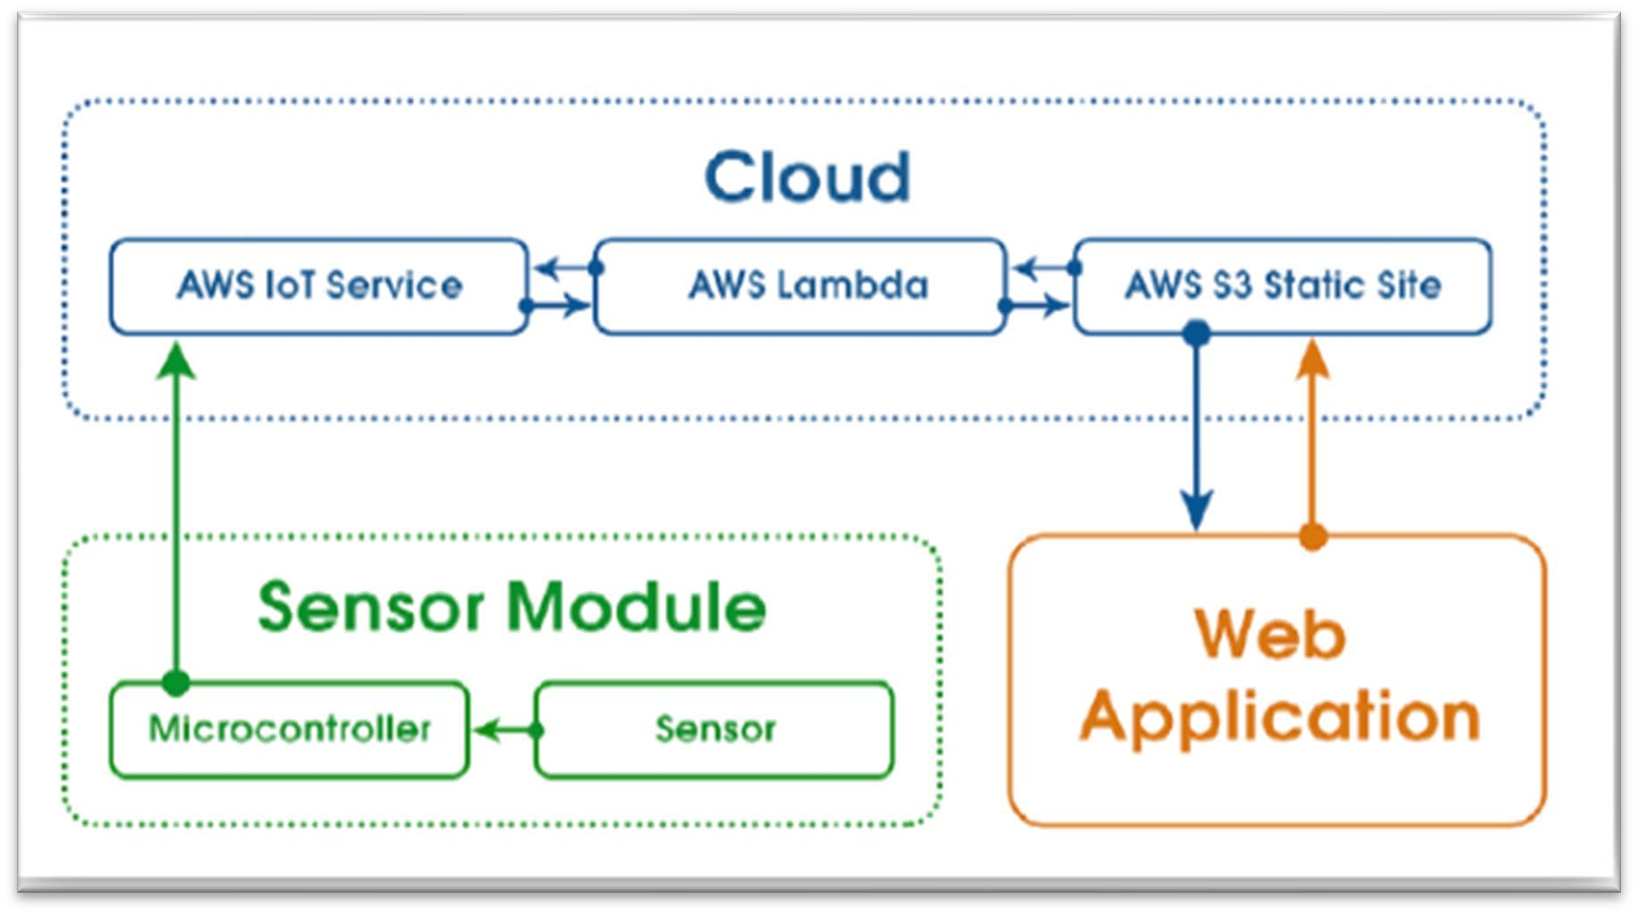

**Fig. 2.1 IoT Cloud**

* 1. **Assumptions and Constraints**
     1. We have assumed that cars have RFID tags with them.
     2. We have unique details (like the EPC or GS1 Electronic Product Code) that of theft cars, staff cars, and VIPs cars.
     3. RFID tag is passive. (Works through the use of electromagnetic energy)
     4. Passive has also two types, but we have used Hard tags (durable materials like metal or plastic).
  2. **Technical Standards**

###### RFID

**IEEE 1451.7-2010** - IEEE Standard for Smart Transducer Interface for Sensors and Actuators--Transducers to Radio Frequency Identification (RFID) Systems Communication Protocols and Transducer Electronic Data Sheet Formats Superseded by **ISO/IEC/IEEE 21451-7-2011**

###### ARDUINO

Arduino UNO TECHNOLOGY, IEEE PAPER, IEEE PROJECT Arduino UNO

Arduino Uno is a microcontroller board based on the ATmega328P. It has a 16 MHz quartz crystal, 6 analog inputs, 14 digital input/output pins (of which 6 can be used as PWM outputs), a USB port, a power jack, an ICSP header, and a reset button.

###### NodeMCU ESP8266

The ESP8266 NodeMCU's technical highlights and distinguishing characteristics include: Micro-USB connectivity and built-in Wi-Fi (IEEE 802.11 b/g/n) makes it simple to utilize for IoT projects; fast processing capability of up to 160 MHz, compared to 16 MHz for the ATmega328p (Arduino)

**CHAPTER-3 DESIGN METHODOLOGY**

* 1. **Proposed Workflow/ Methodology:**

Three stages are involved in finding a place to park a car. Firstly, the area of parking which has devices (Arduino) and the sensors for the communication from the user to the parking space. The cloud services in the second stage serve as a bridge between the parking area and user. The user side is the third stage. Mobile application sends the notification of the availability to the user. Arduino sensors are positioned for each parking slot and the sensors detect the number of parking slots, the number of booked and free slots. In order for the mobile app and sensors to communicate, a WIFI module is used.

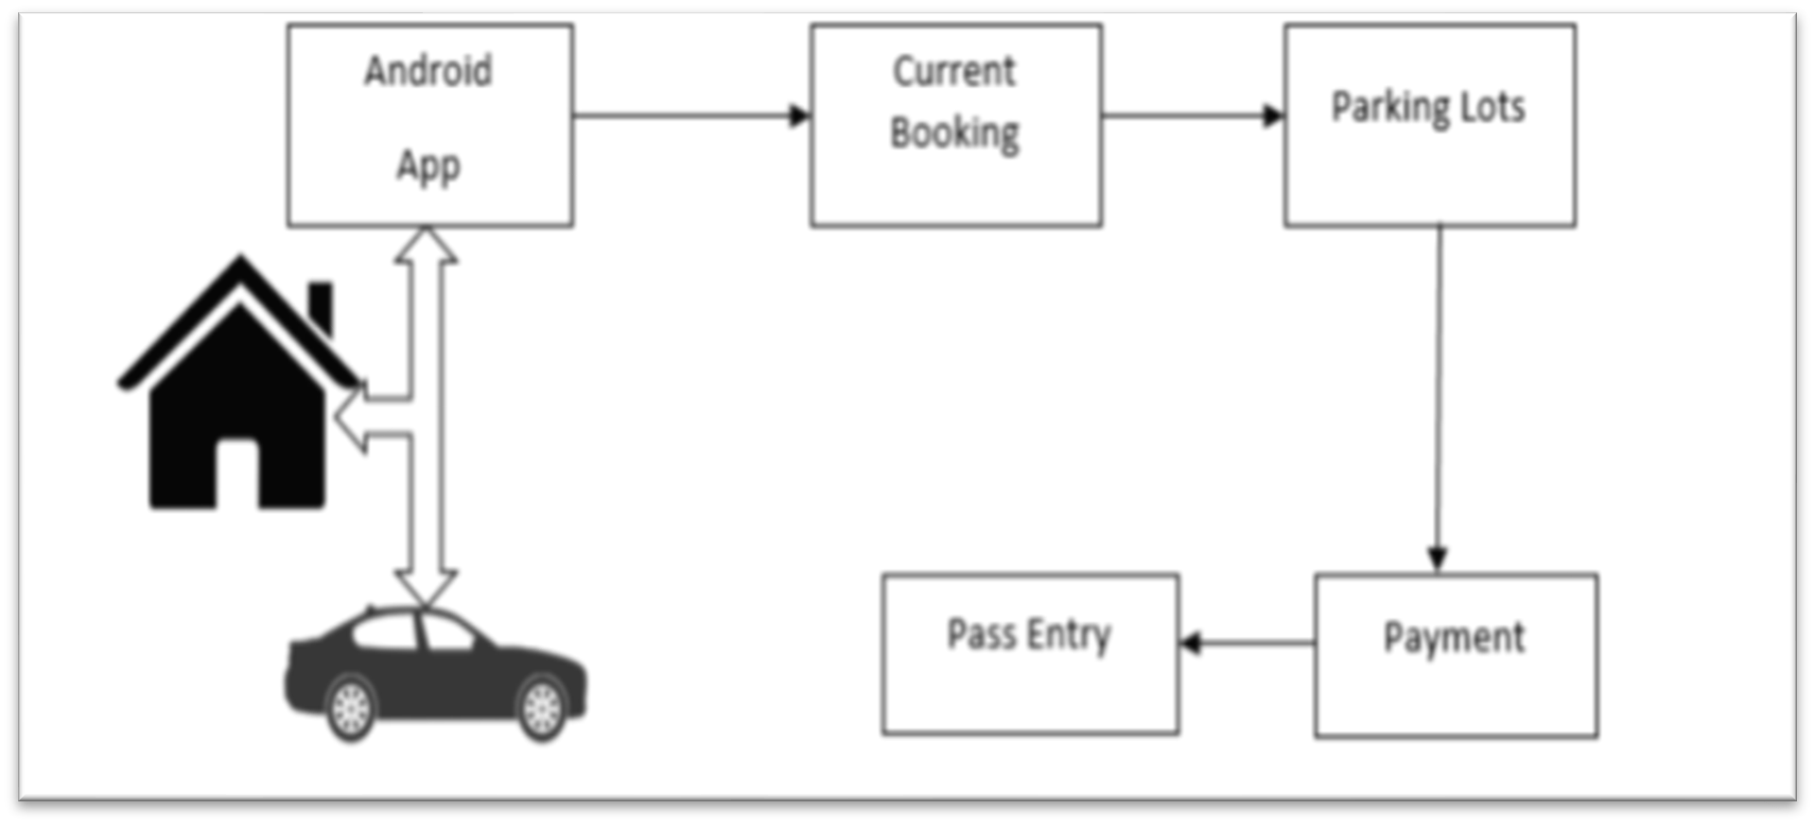

**Fig. 3.1 Payment Gateway**

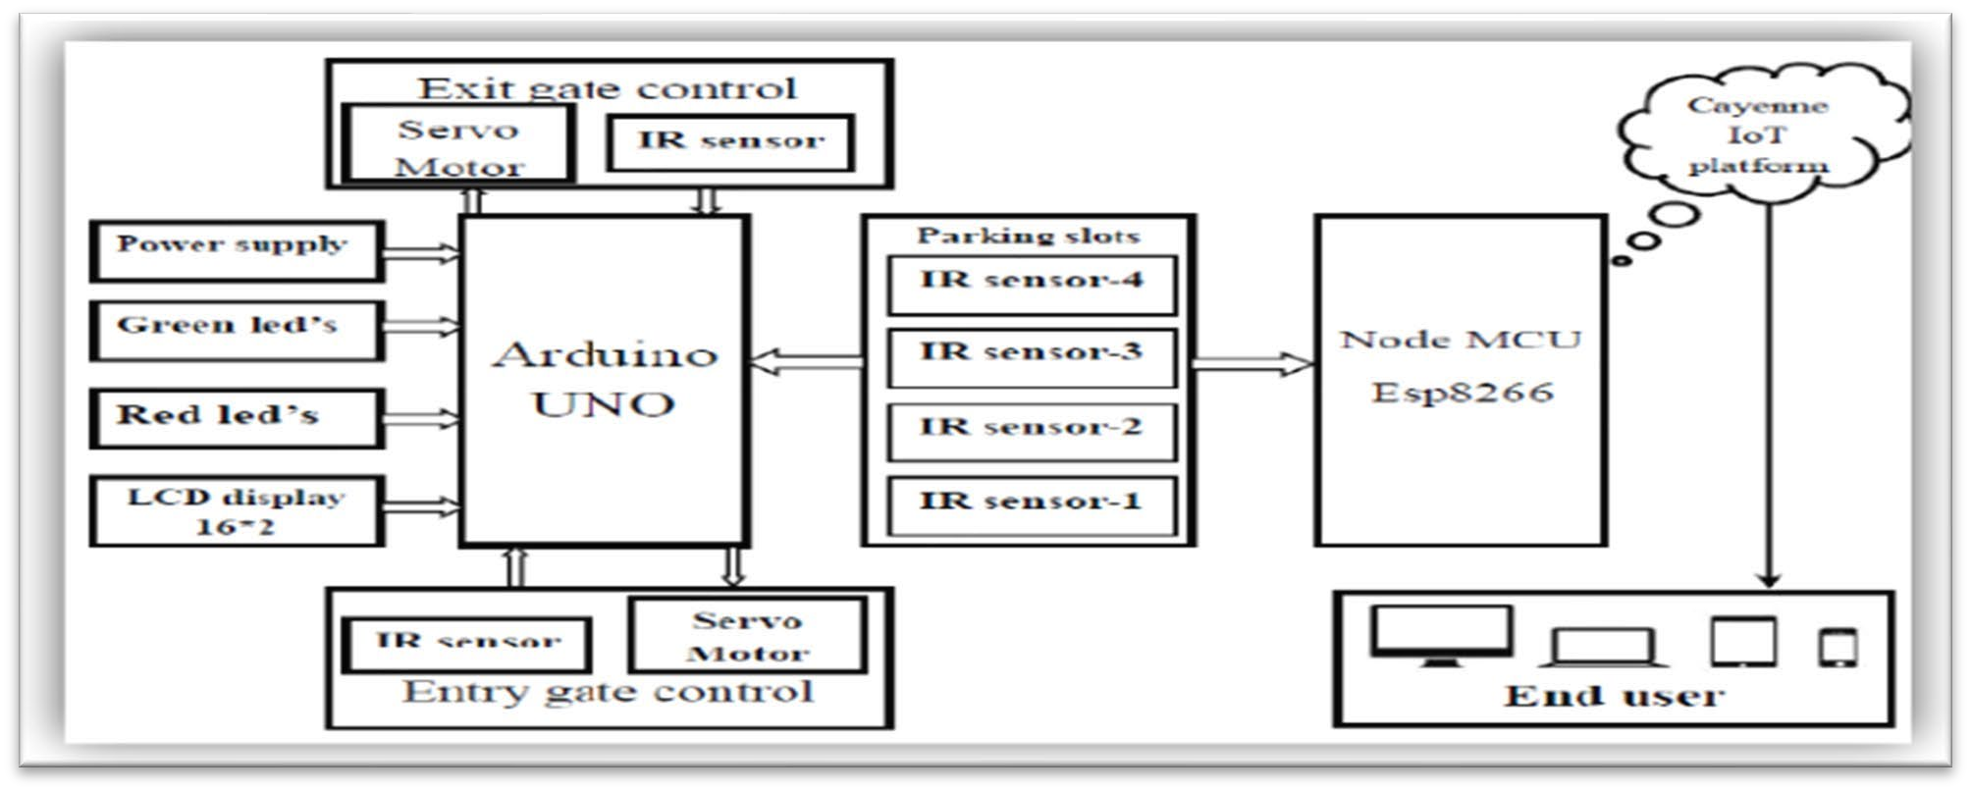

**Fig. 3.2 Block Diagram of IoT**

* 1. **Flow Chart**

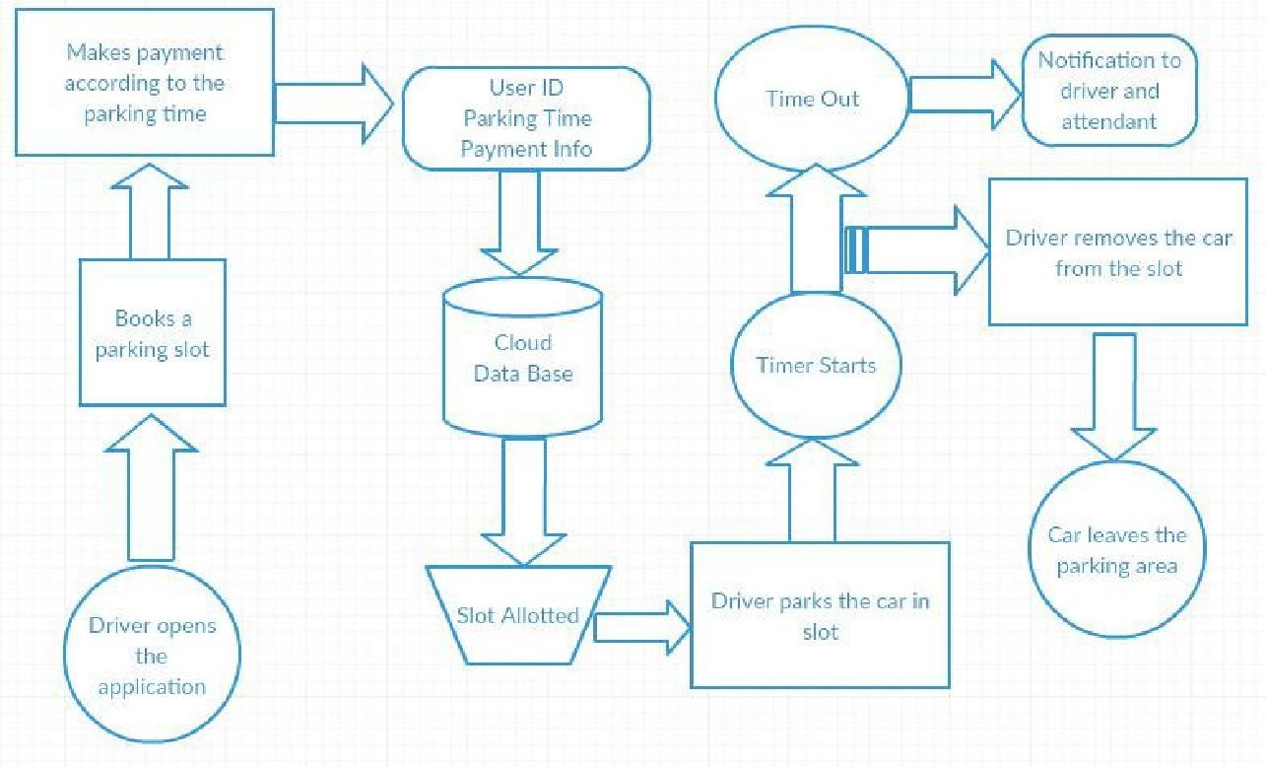

**Fig. 3.3 Methodology**

* 1. **SIMULATION DESIGN:**

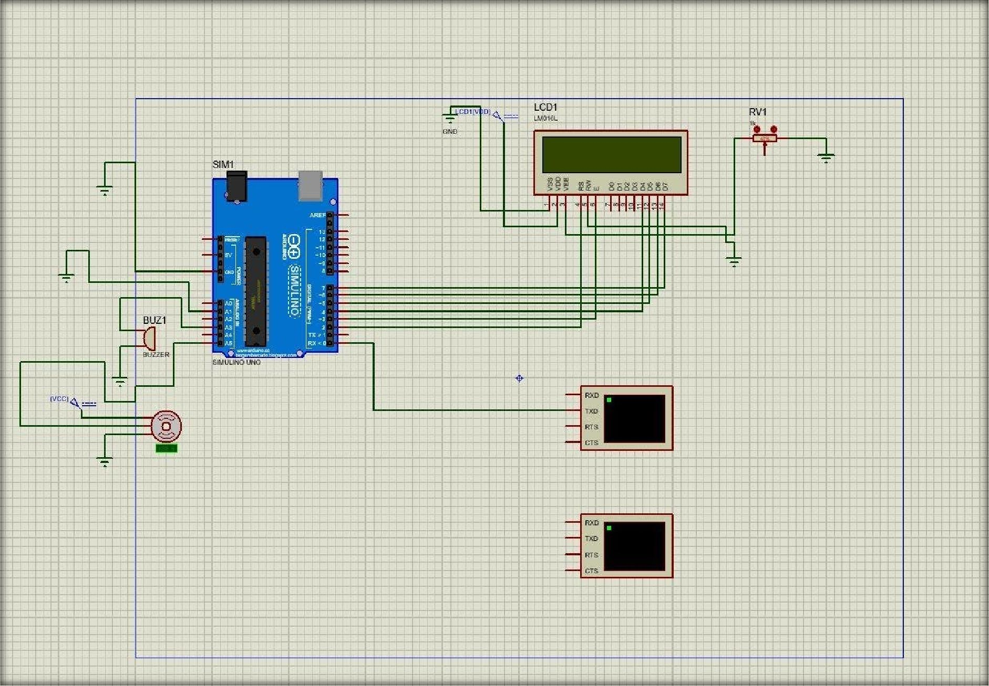

**Fig. 3.4 Simulation Design**

This model has the capacity of containing two cars. At the entrance there are two sensors to detect the presence of a car before it goes inside/outside of the parking slot. To detect the car individually for each parking slot, The parking lot contains the remaining two sensors.

At the entrance to open and close the gate according to the signals sent by the sensors through Arduino, a DC Servo motor has been used. The screen tells us about the system model parking slots. This is a real time display (parking slot status). Since we are using a web-based app, anyone can get the status of the parking slot through their cell phones, laptops, desktops and other internet supporting devices by visiting the website on the URL.

The model of the parking slot has two parking slots and here we can park a maximum number of two cars through the system.

We have used two IR sensors which when parked will send an appropriate message for the user and when all the parking slots are filled the dc motor will not allow new vehicles for parking. Displaying of appropriate message for any action which takes place in the parking zone is done effectively and efficiently

**Network Time protocol**

The Network Time Protocol is a networking protocol for clock synchronization between computer systems over packet-switched, variable-latency data networks. For fetching time from the NTP server We have used NTP so that we can show the start time and end time to the user when he parks or unparks his vehicle.

**Blynk app**

Blynk is an Internet-of-Things platform for iOS or Android smartphones that allows users to remotely control devices like Arduino, Raspberry Pi, and NodeMCU. Using this application, you can compile and provide the right address on the available widgets to create a graphical interface or human machine interface (HMI). We attempted to pop notifications to every conceivable event occurring in the parking zone while using the Blynk app.

A serial algorithm is used to display the slot number to the user who is going to park his vehicle. For example, empty slot numbers are displayed in serial order which gets filled. For the convenience of the customer, if slot 1 is filled and another vehicle arrives, slot 2 is displayed, and so on for all other vehicles. If any vehicle leaves the lot number, the earliest lot number is displayed.

* 1. **Hardware Working**

A driver needs to follow the following steps in order to park its car using our parking system.

* + - **Step 1**: Need to install the parking application on a mobile device.
    - **Step 2:** On the 16*2 The number of vacant and filled spots are displayed so that the user can see the status of the parking zone.
    - **Step 3**: When a user logs into the app he would see the parking architecture with the cars filled at which position and positions that are vacant.
    - **Step 4**: Whenever a user is in the proximity of the parking,the IR sensor detects, he will get a message on his app on which slot he can park his vehicle if there is an empty slot.
    - **Step 5**: If there is no empty slot the user will be displayed with an appropriate message on the mobile application.
    - **Step 6**: On availability of parking area and user parking into the respective slot he/she would obtain a message which states the starting duration of parking and the space where the car is parked.
    - **Step 7**: On un-parking the car from the parking slot he/she will get a message which states the starting time and end time of his parking and an amount which he needs to pay for the parking duration.

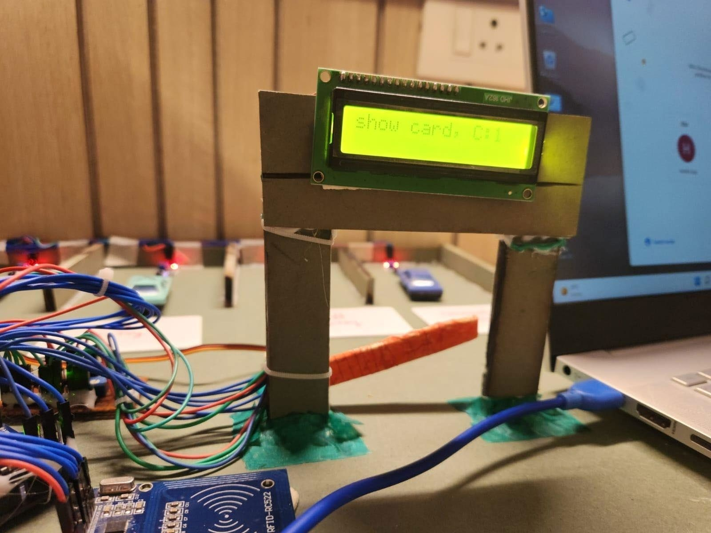

**Fig. 3.5 Hardware View**

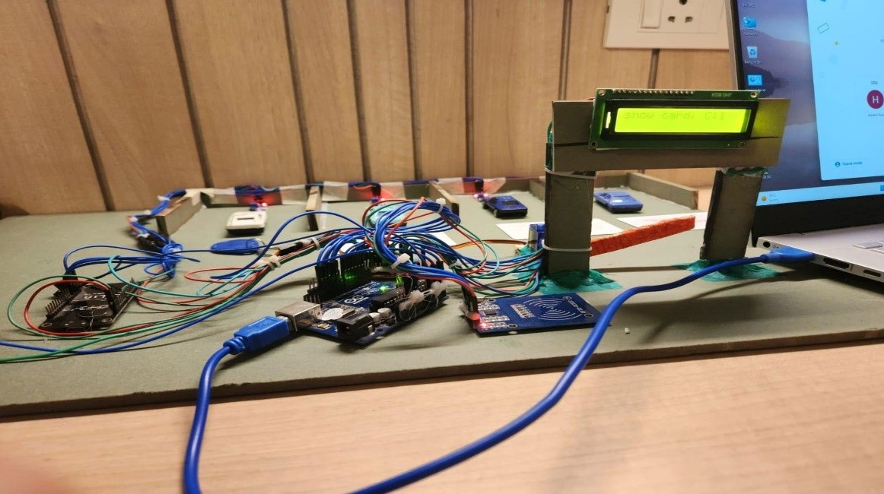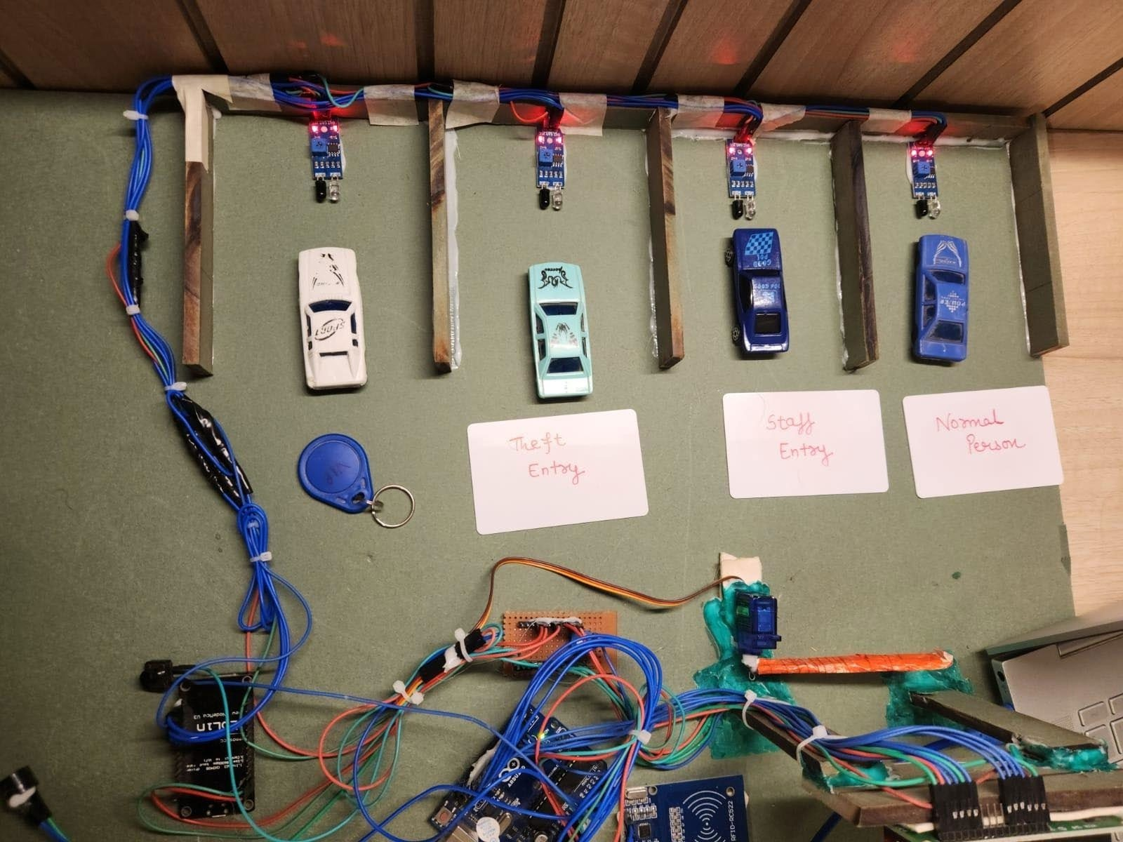

**Fig. 3.6 Hardware View**

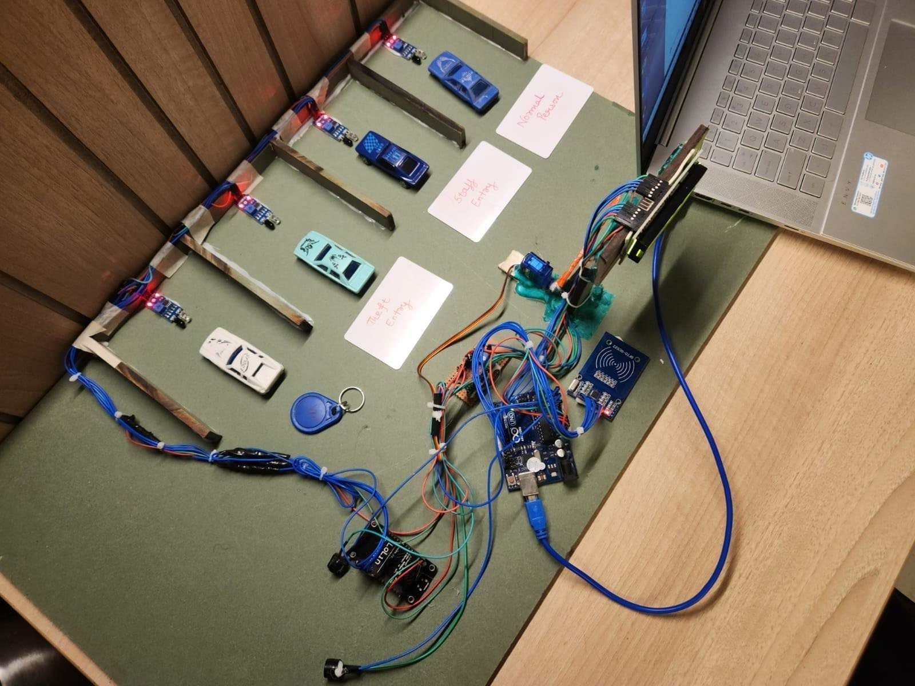

**Fig. 3.7 Hardware View**

This model has the capacity of containing two cars. At the entrance there are two sensors to detect the presence of a car before it goes inside/outside of the parking slot. To detect the car individually for each parking slot, within the parking lot, two additional sensors are installed. At the entrance to open and close the gate according to the signals sent by the sensors through Arduino, a DC Servo motor has been used. The screen tells us about the system model parking slots. This is a real time display (parking slot status).

Since we are using a web-based app, anyone can get the status of the parking slot through their cell phones, laptops, desktops and other internet supporting devices by visiting the website on the URL. The model of the parking slot has two parking slots and here we can park a maximum number of two cars through the system.

We have used two IR sensors which when parked will send appropriate messages for the user and when all the parking slots are filled the dc motor will not allow new vehicles for parking. Displaying of appropriate message for any action which takes place in the parking zone is done effectively and efficiently

**Network Time protocol**

The Network Time Protocol is a networking protocol for clock synchronization between computer systems over packet-switched, variable-latency data networks. For fetching time from the NTP server We have used NTP so that we can show the start time and end time to the user when he parks or unparks his vehicle.

**Blynk app**

Blynk is an Internet-of-Things platform for iOS or Android smartphones that allows users to remotely control devices like Arduino, Raspberry Pi, and NodeMCU. Using this application, you can compile and provide the right address on the available widgets to create a graphical interface or human machine interface (HMI). We attempted to pop notifications to every conceivable event occurring in the parking zone while using the Blynk app.

A serial algorithm is used to display the slot number to the user who is going to park his vehicle. For example, empty slot numbers are displayed in serial order which gets filled. For the convenience of the customer, if slot 1 is filled and another vehicle arrives, slot 2 is displayed.

* 1. **RFID CODE**

int t1=0, t2=0, t3=0, t4=0;

###### // include the library code:

#include <LiquidCrystal.h> #include <Servo.h>

Servo myservo; **// create servo object to control a servo**

###### // initialize the library by associating any needed LCD interface pin

**// with the arduino pin number it is connected to** const int rs = 2, en = 3, d4 = 4, d5 = 5, d6 = 6, d7 = 7; LiquidCrystal lcd(rs, en, d4, d5, d6, d7);

#include <SPI.h> #include <RFID.h> int bal=0;

int charge=20; int bal1=0;

int charge1=20; int bal2=0;

int charge2=20; int bal3=0;

int charge3=20;

#define SDA_DIO 10 **// any available DIO line**

#define RESET_DIO 9 **// any available DIO line**

RFID rfid(SDA_DIO, RESET_DIO);

// Setup variables: int serNum0;

int c=0;

int code_total1; int code_total2; int last_code1; int last_code2;

String user = ""; void setup()

{

Serial.begin(9600);

lcd.begin(16, 2);

// Print a message to the LCD. lcd.setCursor(0, 0); lcd.print("show card");

SPI.begin();

###### /* Initialization of the RFID readers */

rfid.init();

Serial.println("Setup"); pinMode(A1, INPUT); digitalWrite(A1, HIGH);

/// pinMode(A2, INPUT);

//digitalWrite(A2, HIGH); pinMode(A3, OUTPUT); digitalWrite(A3, LOW);

// pinMode(A4, OUTPUT);

// digitalWrite(A4, LOW); myservo.attach(A5); myservo.write(0);

}

void loop()

{

lcd.setCursor(0, 0); lcd.print("show card, C:"); lcd.print(c);

lcd.print(" ");

if (rfid.isCard()) {

if (rfid.readCardSerial()) {

/* With a new cardnumber, show it. */ Serial.println(" "); Serial.println("Card found"); serNum0 = rfid.serNum[0];

//Serial.println(" "); Serial.println("Cardnumber:"); Serial.print("Dec: ");

Serial.print(rfid.serNum[0],DEC);

Serial.println(" "); if(rfid.serNum[0]== 144 && t1==0)

{

c++;

rfid.serNum[0]= 0; t1=1;

if(bal==0)

{

lcd.setCursor(0, 1);

lcd.print("Recharge Now! "); while(digitalRead(A1)==1);

if(digitalRead(A1)==0)

{

bal=500;

}

lcd.setCursor(0, 1); lcd.print("Recharge Done!"); delay(3000); lcd.setCursor(0, 1); lcd.print(" ");

}

lcd.setCursor(0, 1); lcd.print("Entry Done! "); lcd.print(bal); digitalWrite(A4, HIGH); myservo.write(90); delay(3000); myservo.write(0); digitalWrite(A4, LOW); lcd.setCursor(0, 1); lcd.print(" ");

}

if(rfid.serNum[0]== 144 && t1==1)

{

c--;

rfid.serNum[0]= 0; t1=0;

bal = bal-charge; lcd.setCursor(0, 1); lcd.print(bal); lcd.print(" Thank u"); myservo.write(90); delay(3000); myservo.write(0); lcd.setCursor(0, 1); lcd.print(" ");

}

if(rfid.serNum[0]== 150 && t2==0)

{

c++;

rfid.serNum[0]= 0; t2=1;

lcd.setCursor(0, 1); lcd.print("VIP Entry Done! ");

digitalWrite(A4, HIGH); myservo.write(90); delay(3000);

myservo.write(0); digitalWrite(A4, LOW); lcd.setCursor(0, 1); lcd.print(" ");

}

if(rfid.serNum[0]== 150 && t2==1)

{

c--;

rfid.serNum[0]= 0; t2=0;

lcd.setCursor(0, 1);

lcd.print(" Thank u"); myservo.write(90); delay(3000); myservo.write(0); lcd.setCursor(0, 1); lcd.print(" ");

}

if(rfid.serNum[0]== 112 && t3==0)

{

c++;

rfid.serNum[0]= 0; t3=1;

lcd.setCursor(0, 1);

lcd.print(" Staff Entry Done! ");

digitalWrite(A4, HIGH); myservo.write(90); delay(3000); myservo.write(0); digitalWrite(A4, LOW); lcd.setCursor(0, 1); lcd.print(" ");

}

if(rfid.serNum[0]== 112 && t3==1)

{

c--;

rfid.serNum[0]= 0; t3=0;

lcd.setCursor(0, 1);

lcd.print(" Thank u"); myservo.write(90); delay(3000); myservo.write(0); lcd.setCursor(0, 1);

lcd.print(" ");

}

}

if(rfid.serNum[0]== 240 && t4==0)

{

c++;

rfid.serNum[0]= 0; t4=1;

lcd.setCursor(0, 1);

lcd.print(" Theft Entry Done! ");

digitalWrite(A3, HIGH); myservo.write(90); delay(3000); myservo.write(0); digitalWrite(A3, LOW); lcd.setCursor(0, 1); lcd.print(" ");

}

if(rfid.serNum[0]== 240 && t4==1)

{

c--;

rfid.serNum[0]= 0; t4=0;

lcd.setCursor(0, 1);

lcd.print(" Thank u"); myservo.write(90); delay(3000); myservo.write(0); lcd.setCursor(0, 1); lcd.print(" ");

}

}

delay(300)

}

**CHAPTER-4 RESULTS AND DISCUSSION**

* 1. **Simulation Results**

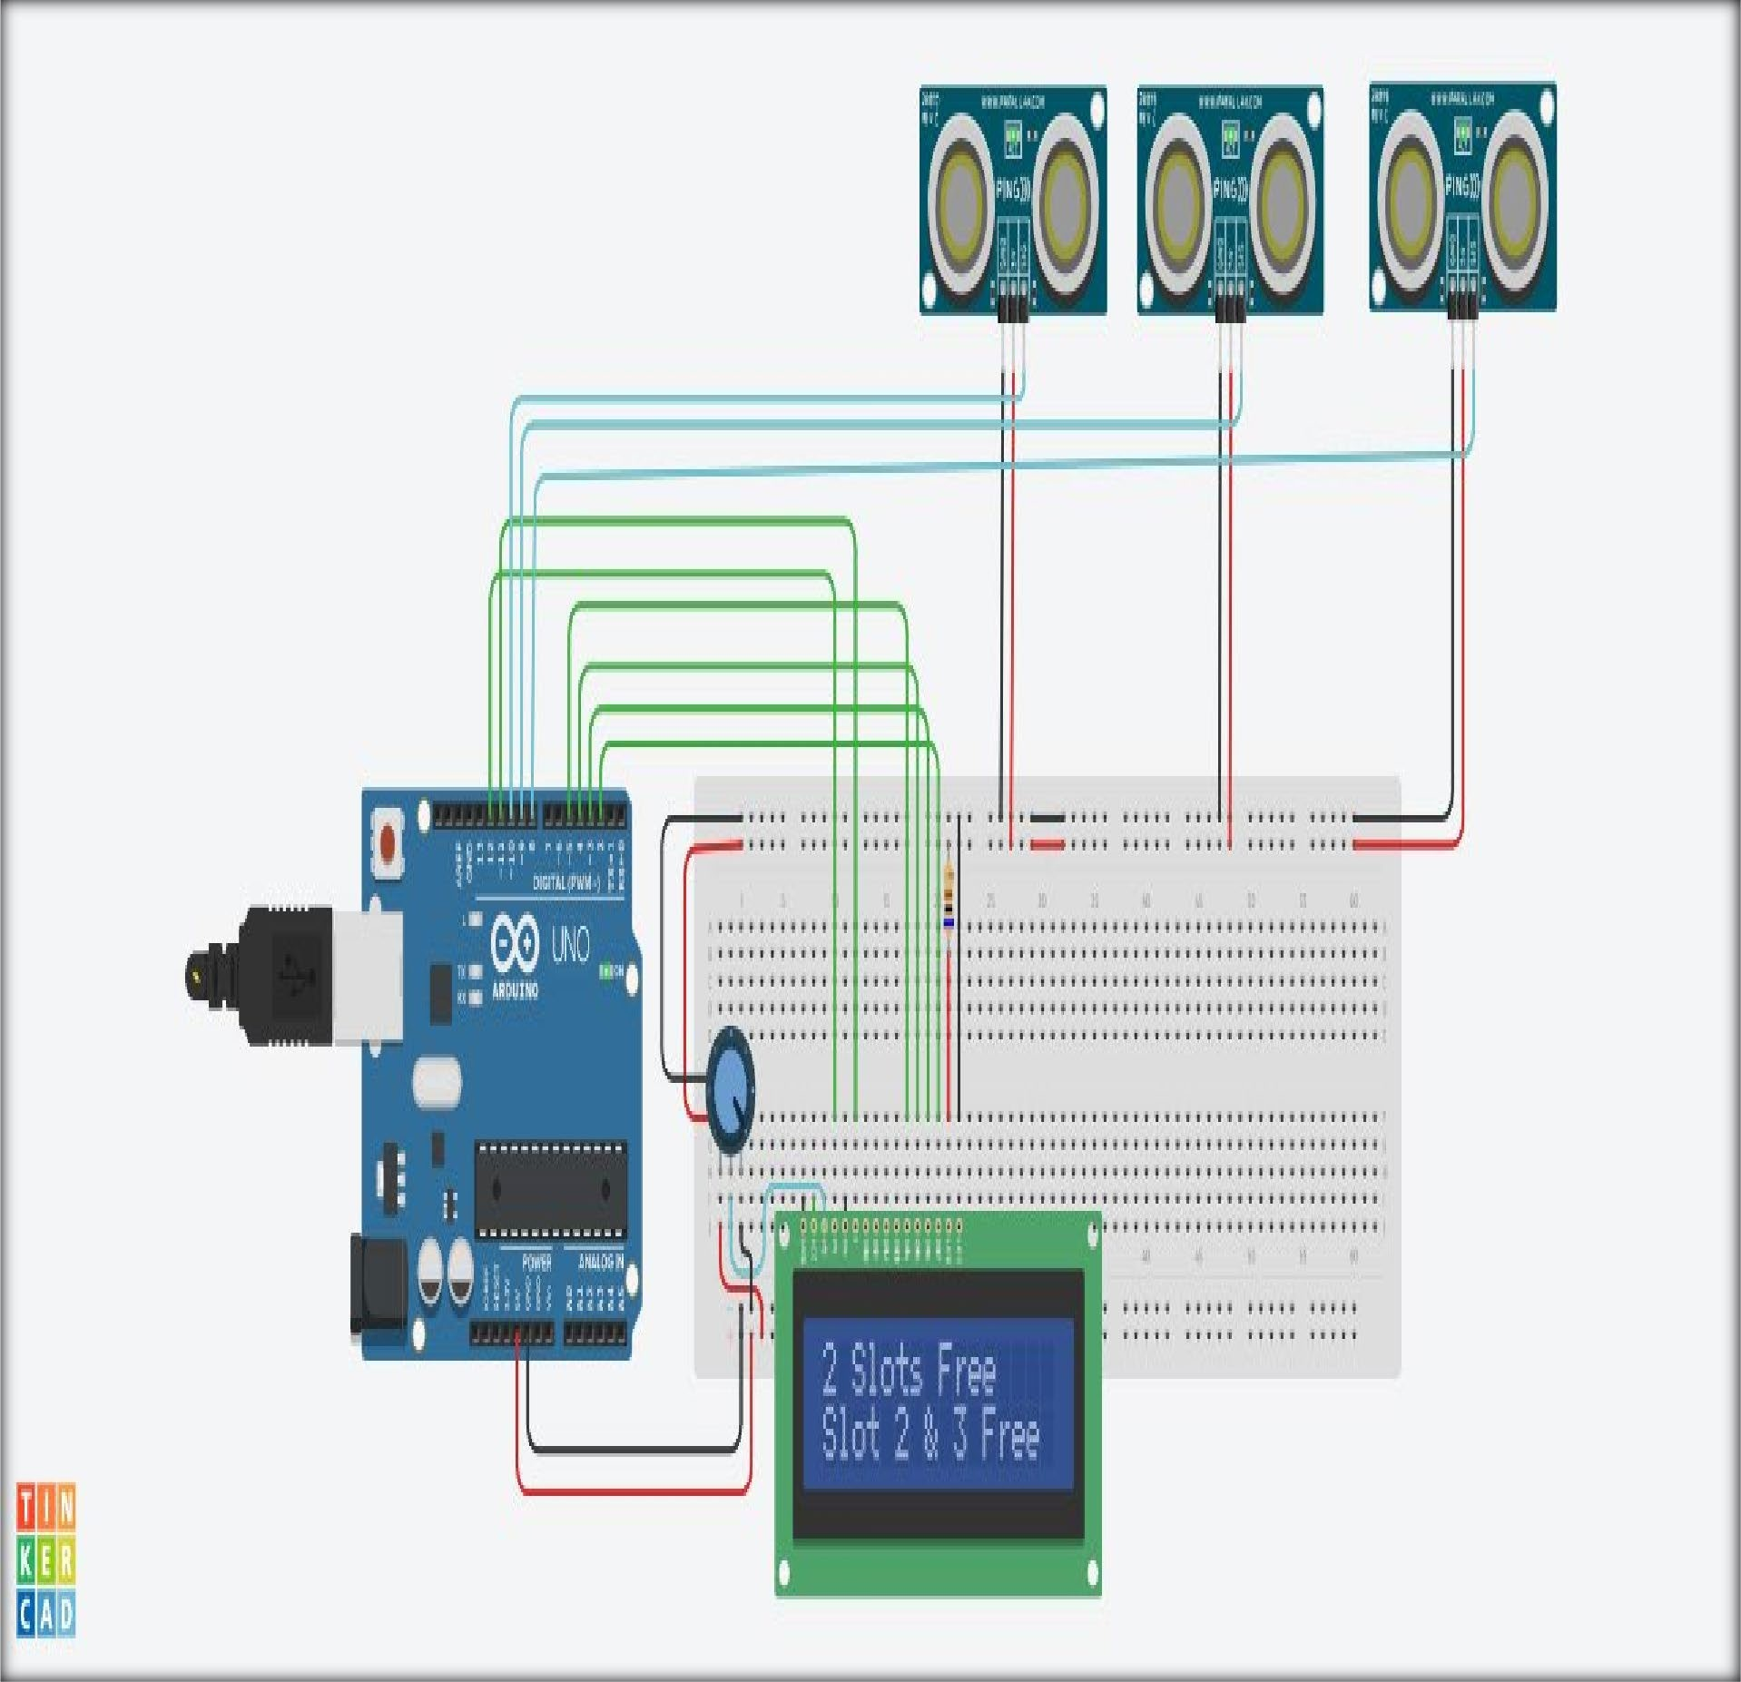

**Fig. 4.1 Tinker CAD Design**

## Serial Monitor Output

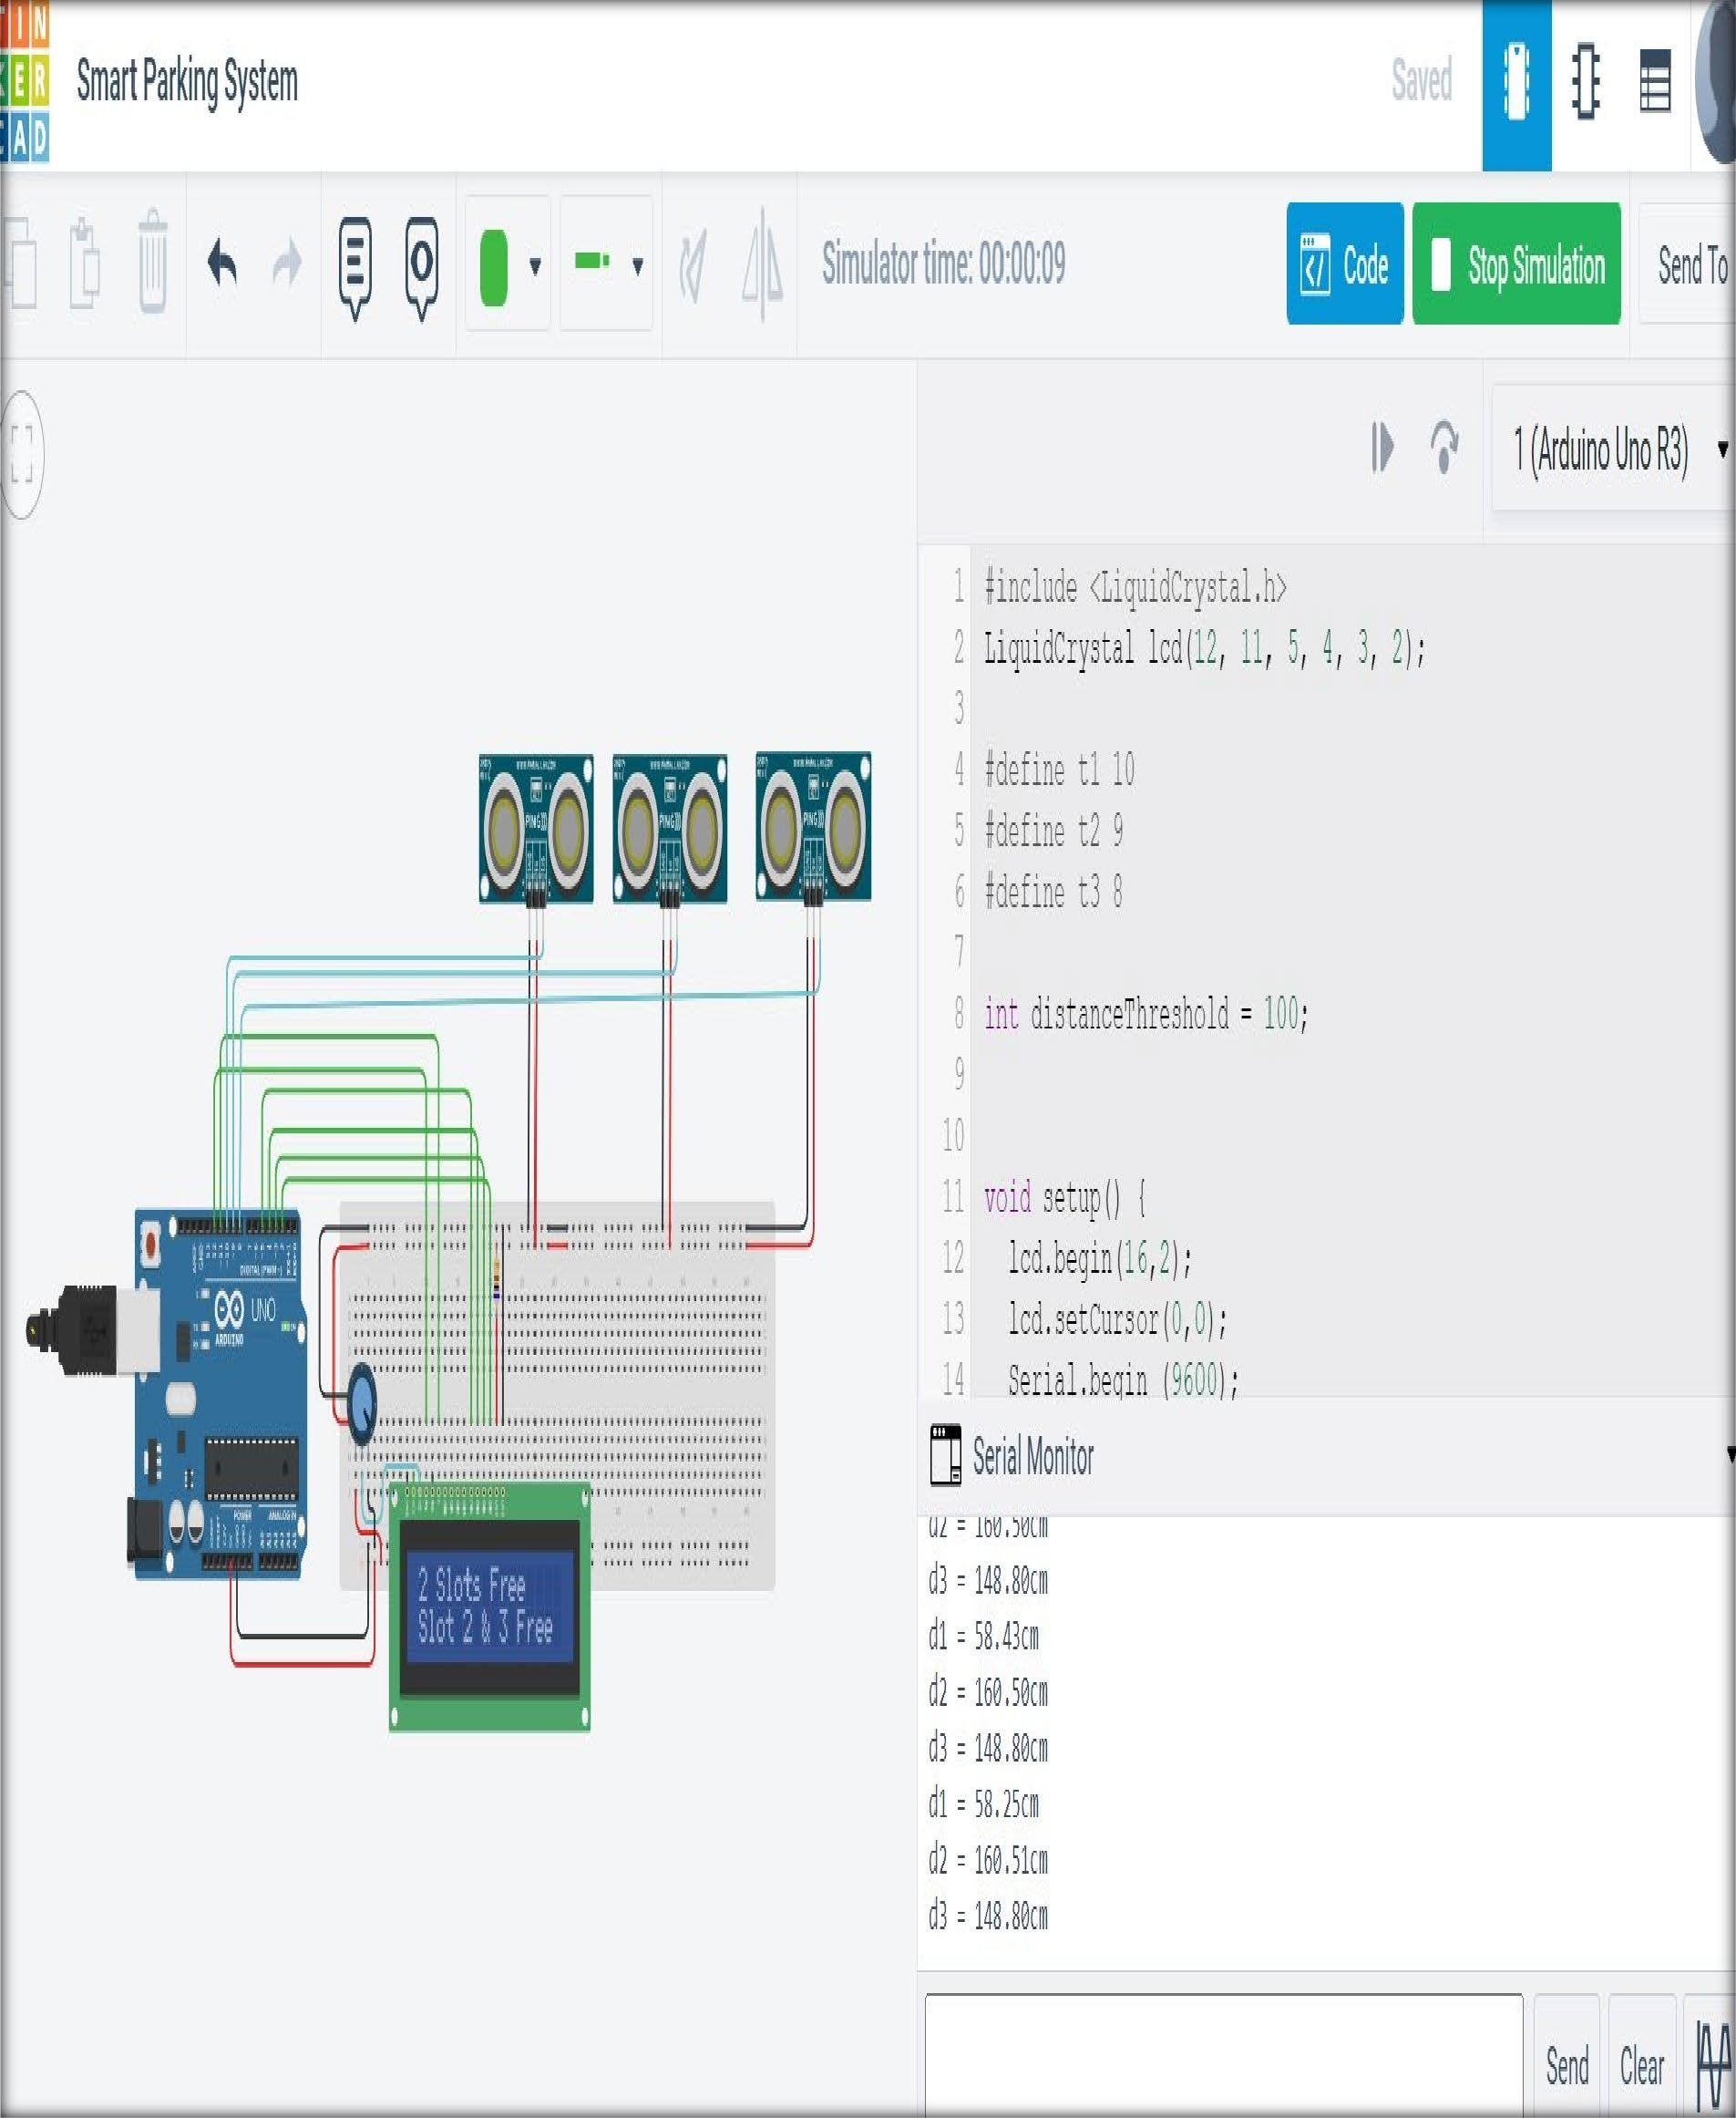

**Fig. 4.2 Tinker CAD Design**

## Schematic Diagram

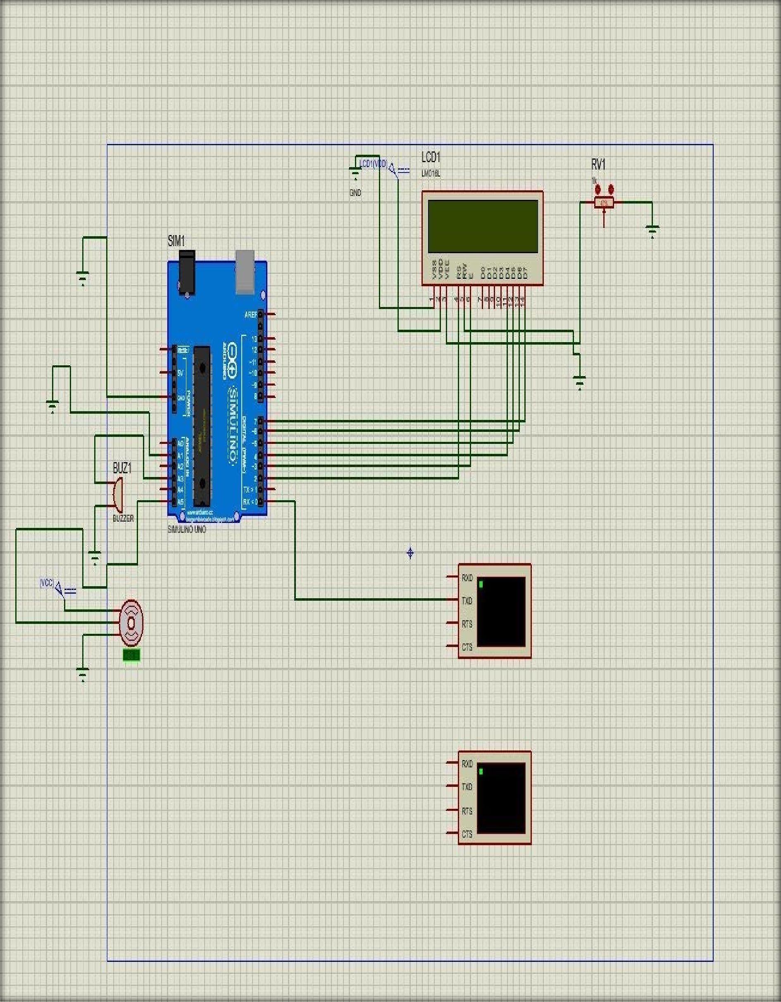

**Fig. 4.3 Proteus Simulation Design**

## Hardware Results

We are offering a novel method for RFID-based theft prevention and detection systems in this IOT-based intelligent parking system. The system we are creating is basically just a demonstration model or prototype.

The passive RFID chips that would be concealed within the car and serve as the vehicle's identifying number are vital to this technology. A centralized server will keep track of the data related to these tags. A network of RFID scanners spread out over the city's checkpoints, traffic signals, and toll booths will search for the reported tag after an authorized user enters a complaint of any auto theft into the system. The surveillance system would be installed when it is deemed required.

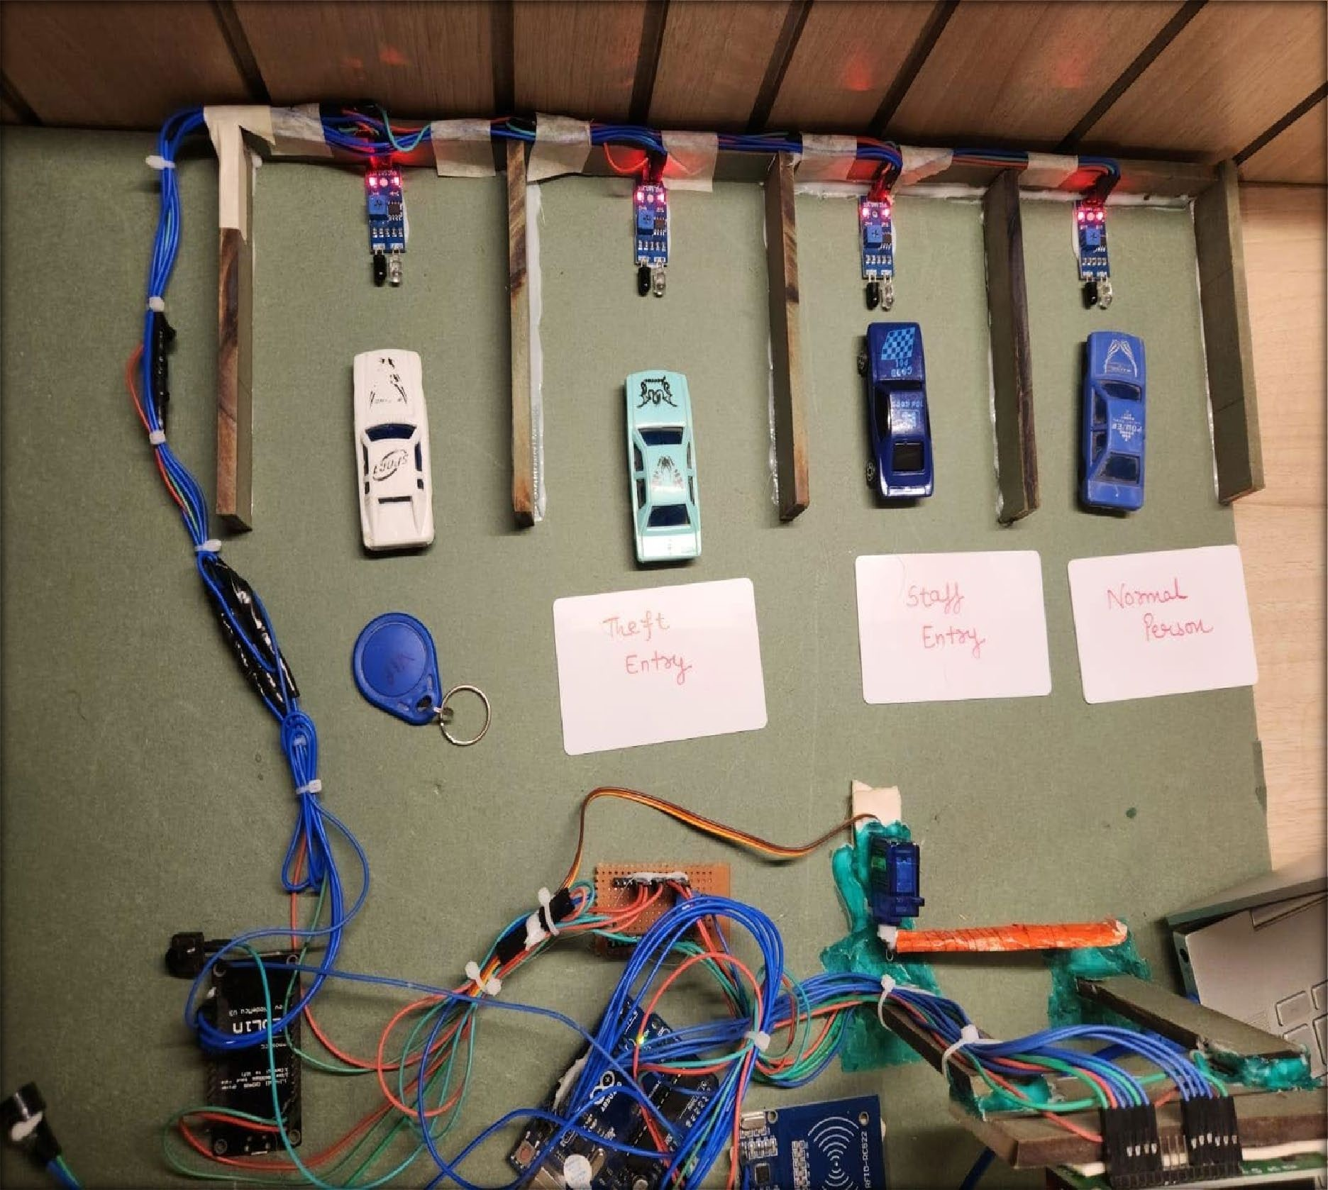

**Fig. 4.4 Hardware View**

* 1. **Discussion and Inferences Drawn**
     + The IOT based smart parking system is acquired as a medium to resolve parking issues not only in the present time but also in the future. Moreover, IoT techniques should be given awareness.
     + It also stops vehicles from needlessly driving across occupied parking spaces in a metropolis. The solution to the pollution issue in a city is the development of smart parking systems.
     + Gasoline conservation (According to recent studies, Smart Parking Systems could save about 8,31,600 liters of fuel by 2030 and roughly 11,34,000 liters of fuel by 2025.)
     + Automated parking systems also help in improving the lifestyle of many car owners and also saving their time while parking around certain areas such as the mall’s, school’s, and airport’s etc.
     + The information provided by the smart parking system improves system efficiency by drastically reducing vehicle travel and search times. With the information provided, drivers can easily find available parking spots and steer clear of fully occupied car parks.
     + The solution that we suggest offers information about the number of parking slots that are available in a parking location in a real time environment. By using our web application, anybody from any location could reserve a parking space for themselves.

## Justification of Objectives Achieved

* + - This designed IOT based smart parking system is straightforward, economical, and gives an efficient solution to diminish **GreenHouse Gases** in the atmosphere.
    - Through the online application, the status of parking slots is accessed and tracked from any faraway location. As a result, finding parking spaces in any parking location takes less time.
    - It also prevents vehicles from idling through occupied parking slots in the city which in turn saves time and offers affordability.
    - Smart parking systems eases the problems of urban habitability, transportation Portability, and environmental sustainability.It is used for enhancing the **productivity** and **service** in operations.
    - It is greatly managed in accessing and mapping the position of parking spaces via the internet from any location. It aids in reducing unnecessary vehicle movement across occupied parking spaces in a city.
    - The entrance and exit of a parking space will be counted with great accuracy by the sensor because laser scanning sensors are well renowned for their accuracy in identifying the presence of a car.
    - The sensors will just count the vehicles without recording any data. The system is not based on cameras, but again on sensors and eventually a display for counting the cars.

# CHAPTER-5 CONCLUSION AND FUTURE WORK

## Conclusion

Some issues like urban sustainability, environmental sustainability and transit mobility are essentially the main drivers or enablers for smart parking. The utmost aim of smart parking technology is to increase service standards and operational productivity. Some benefits which are underlying include lowering the cost of operation while enhancing customer value to promote occupancy, facility value, and revenue.

The addition of automated pay stations, gates, and metres has transformed traditional service channels like toll booths and parking attendants. The parking sector is a $25 billion global market. In this industry, minimalistic innovations and implementations have been observed. Energy-efficient hybrid and electric vehicles have seen the majority of investments, the problem of global gridlock is still not solved and the same burden on traffic in cities. Utilizing low-cost sensors, real-time data, and applications that track available and unavailable parking spaces are all part of smart parking. To reduce the manually consuming time looking to find the best parking level, location, or even lot, the procedure will be automatic. Some solutions will offer a comprehensive selection of services, such as online payments, reminders when parking permits are about to expire, and even the ability to search for specific vehicles in very large parking lots.

The lengthy course, composition of our urban landscapes can be transformed using a smart parking system, making them more tolerant of people than of vehicles. As the success and market readiness of the autonomous vehicle ecosystem depend on the gathering and analysis of data at the ground level, vehicle-to-vehicle and street-to-vehicle communication will be crucial.

This model has the capacity of containing two cars. At the entrance there are two sensors to detect the presence of a car before it goes inside/outside of the parking slot. To detect the car individually for each parking slot, The parking lot contains the remaining two sensors.

At the entrance to open and close the gate according to the signals sent by the sensors through Arduino, a DC Servo motor has been used. The screen tells us about the system model parking slots. This is a real time display (parking slot status). Since we are using a web-based app, anyone can get the status of the parking slot through their cell phones, laptops, desktops and other internet supporting devices by visiting the website on the URL.

The model of the parking slot has two parking slots and here we can park a maximum number of two cars through the system.

## Future Work

In present times there are several countries which have the portal from which we can gather information about parking spaces through the internet. Information about the parking space can be given to users using this system, but it cannot tell us whether the parking lot is occupied and vacant. So, this issue cannot be handled smartly with this system. When a car enters the parking lot, Car gets lifted with an automatic robot system, which takes automatically the car to a specific parking lot. Medium scale movie theatres, shopping malls cannot install this system as it will cost them an amount which is higher than its benefits. While the system at some places is like it cannot show the exact path and slot to the slot available and can show only availability. Hence, there is the need to smartly find the path to the vacant spot.

It is the demand of the smart parking system which is increasing day by day. The availability of the parking space can be accessed by the user in real time. Today's existing system doesn’t contain the facilities of parking lot availability checker and parking reservation. The previous system is like a manual monitoring system that can guess the number of lots available in a parking area by counting the outgoing and incoming cars and this wastes a lot of effort and time. A further new existing system was a sensor-based system that uses, for determining the car’s presence, the ultrasound waves and then a new that is two tier parking system that uses the idea of parking vehicles one above other parking system came into existence. The outcome of this paper is to reduce the parking time, connect the world with parking info and can be economical to the user. One aim is to decrease the car theft cases. One major benefit is that it reduces the fuel usage as the vehicle will take less time to find the parking lot.

# CHAPTER-6 PROJECT METRICS

## Challenges Faced and Troubleshooting

A student faces a plethora of problems while developing the project. Yet, proper measurements and right steps in the starting can give a better road for the development process. Given below are some of the problems we faced during the process of making the project.

###### Deciding goals and objectives:

Having A comprehensible understanding of what is needed and what is to be done is very crucial for proper completion of a project. A variety of problems like, stakeholder management and including ineffective resources, can result from not deciding adequate objectives and goals.

* + 1. **Changes and constraints in budget:** In terms of economics, the total number of things which can be bought with the money available in the pocket is the budget constraint. The total number of electronic equipment we can buy within our current budget is our budget constraint. Several options have to be left out because of the budget restrictions which is detrimental for a better project building.
    2. **Component Selection:** Technical and non-technical aspects can be roughly categorised as factors to be considered when choosing a component.
    3. **Work Delay:** There was a work delay that we faced at many instances due to MST or EST and in the recent months due to campus placements.

Due to this the efficiency of the group took a hit and we faced a huge challenge in maintaining the same continuity as we were doing in the starting of the capstone project.

* + 1. **Risk Management:** For the monitoring, limiting and controlling the impact or likelihood of unfortunate events and for the maximisation of the realisation of possibilities, risk management makes sure and add the appraisal, identification, and

prioritisation of risks (defined by ISO 31000 as the influence of uncertainty on objectives).

* + 1. **Learning New Skills:** We learnt new skills during the whole course of our capstone project which includes learning Arduino IDE Coding language, IOT and many different aspects related to RFID sensor working.
    2. **Ideal Proposal:** Biggest challenge for us was to propose an ideal idea of our project as it is quite evident that it should include the project purpose, goals, objective, method and anticipated impact.
  1. **Relevant Subjects and Interdisciplinary Aspect**

Relevant Subjects, applications of whom which we have included in our project are as follows:

* + 1. Engineering Design -II
    2. Microprocessor & Microcontroller
    3. Engineering Design – I
    4. Object Oriented Programming 5. C & C++.

As its quite evident from the above list that we have humongous inclusion of interdisciplinary aspect and it includes:

1. Learning various coding languages like C and C++ and OOPs.
2. We also learned about IOT and what its application is and how we can integrate it ESP- 822 module.

## Components Used

Smart parking systems usually collect data of the availability of parking lots in a certain region and process it in real-time to give position to vehicles in those lots. It comprises the use of less expensive sensors, real-time data collection, and automatic payment systems which can be used

by cell phones, allowing individuals to guess parking availability accurately and to reserve slots in advance.

Thus, after the implementation, this system decreases vehicle emissions in cities by removing the problem of the need for without reason walking round the area blocks looking for space. Cities may carefully regulate their parking supply thanks to this. Unlawful parking and finding empty parking places are two main issues with driving in urban areas. The method for gathering the data was fairly straightforward. We have an infrared sensor (also known as a proximity or IR sensor) that we utilize to gather data on whether a parking space is available or occupied.

We physically attached the sensor to the parking space so that once it is triggered, it would send the info to the remote server where it will be stored or updated in the database because it is connected to the internet. Following is a list of the many tools and materials we utilised to carry out the project:

* + 1. **NodeMcu**: ESP-8266 NodeMCU **(Fig 6.1)** is an open source Internet of Things platform.The hardware of nodemcu is based on the ESP-12 module and firmware is based on the ESP8266 Wi-Fi SoC(Espress if Systems). By default, rather than referring to devices it refers to firmware. Lua-cjson, and spiffs are some of the open source projects which are used by it.

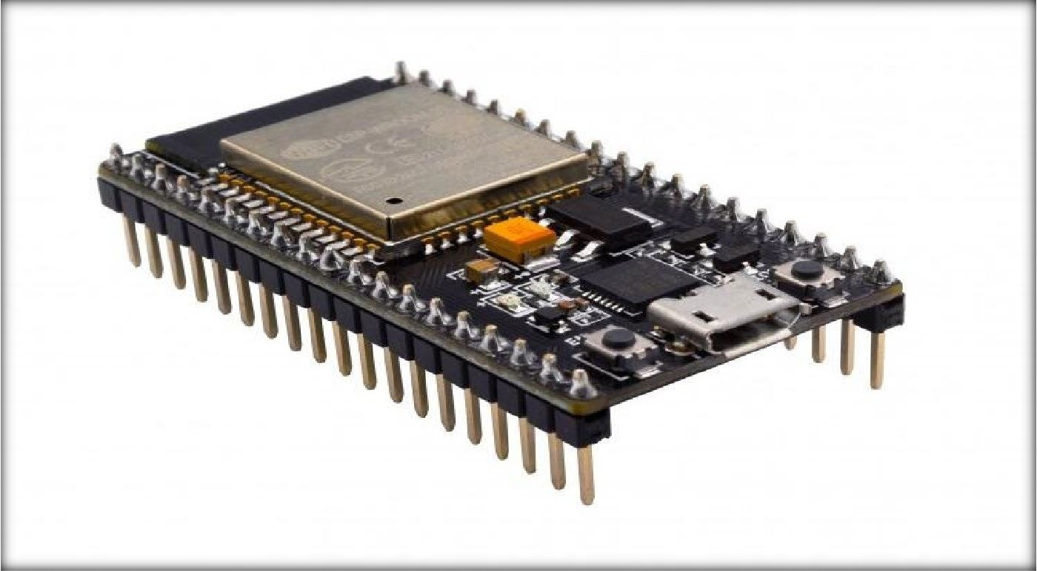

**Fig 6.1 NodeMCU**

* + 1. **IR Sensor**: An electrical device known as an infrared sensor **(Fig 6.2)** uses infrared radiation to detect and/or emit specific features of its environment It is an electrical device which can emit and detect infrared radiations and can be used to get some info of its environment. Besides the sensing motion, the heat emitted can also be detected using it.

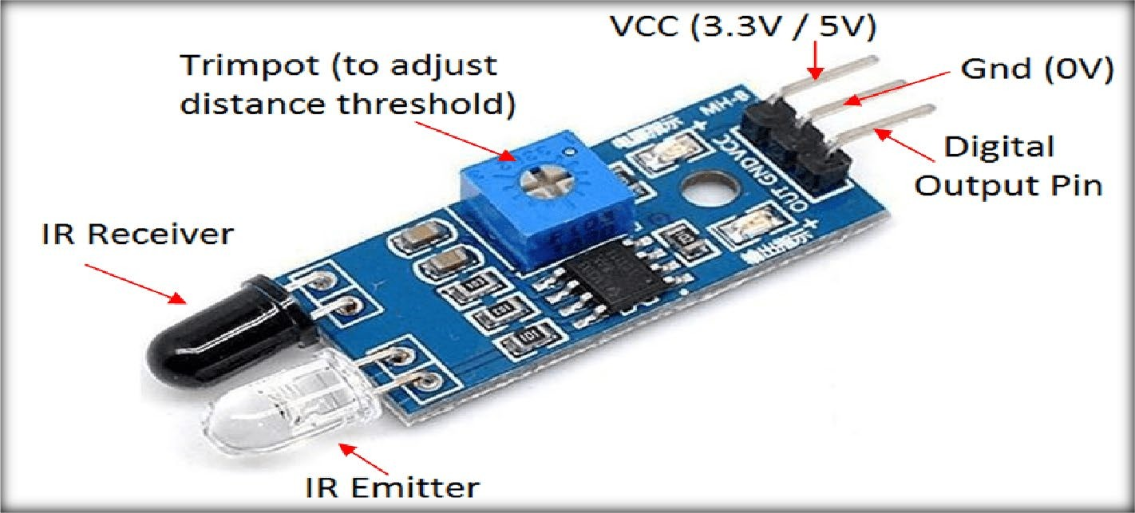

**Fig. 6.2 IR Sensor**

**Principle of IR Sensor**: The operation of a light sensor has already been covered. In order to detect a certain light wavelength in the infrared (IR) spectrum, IR sensors employ a particular light sensor. We can use a LED that produces rays of a certain wavelength which the sensor is looking for and the intensity of received light can be judged. If an object is in the proximity of the sensor,the rays from emitted will reflect back and will be detected by the sensor. This sudden increase in the intensity can be witnessed using a threshold.

* + 1. **RFID Card**: These cards **(fig 6.3)** are made up of substrate ,antenna and an integrated circuit (IC). It is a credit card or identification badge which sends its recording of an object to the reader module. These cards send info about an object using radio waves. These may also be beneficial for tracking the vehicles to which they are attached.

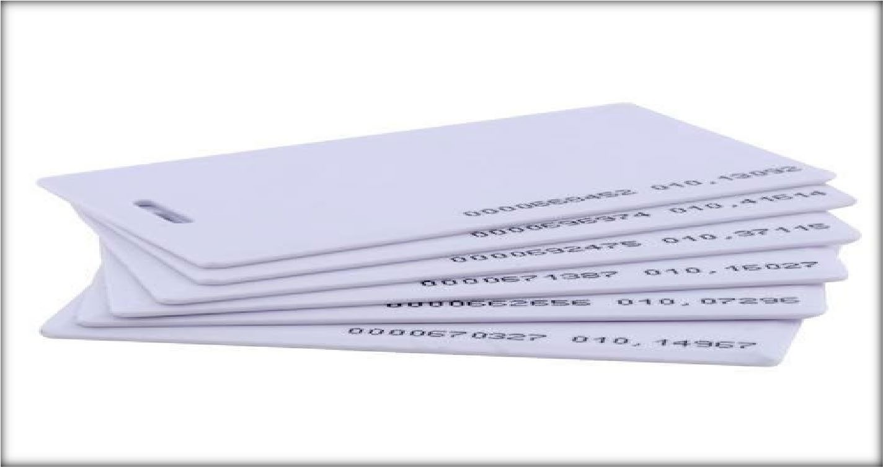

**Fig. 6.3 RFID Card**

* + 1. **Arduino:** Arduino is a microcontroller and contains software and hardware which is easy to use. It has a ready made software - arduino integrated development environment (IDE) circuit and aboard which we can programme. The IDE can be used to upload and write the computer code on the physical board. It can give voltage outputs which can be used for several purposes. These days arduino is used for many purposes like projects and demonstrating things.

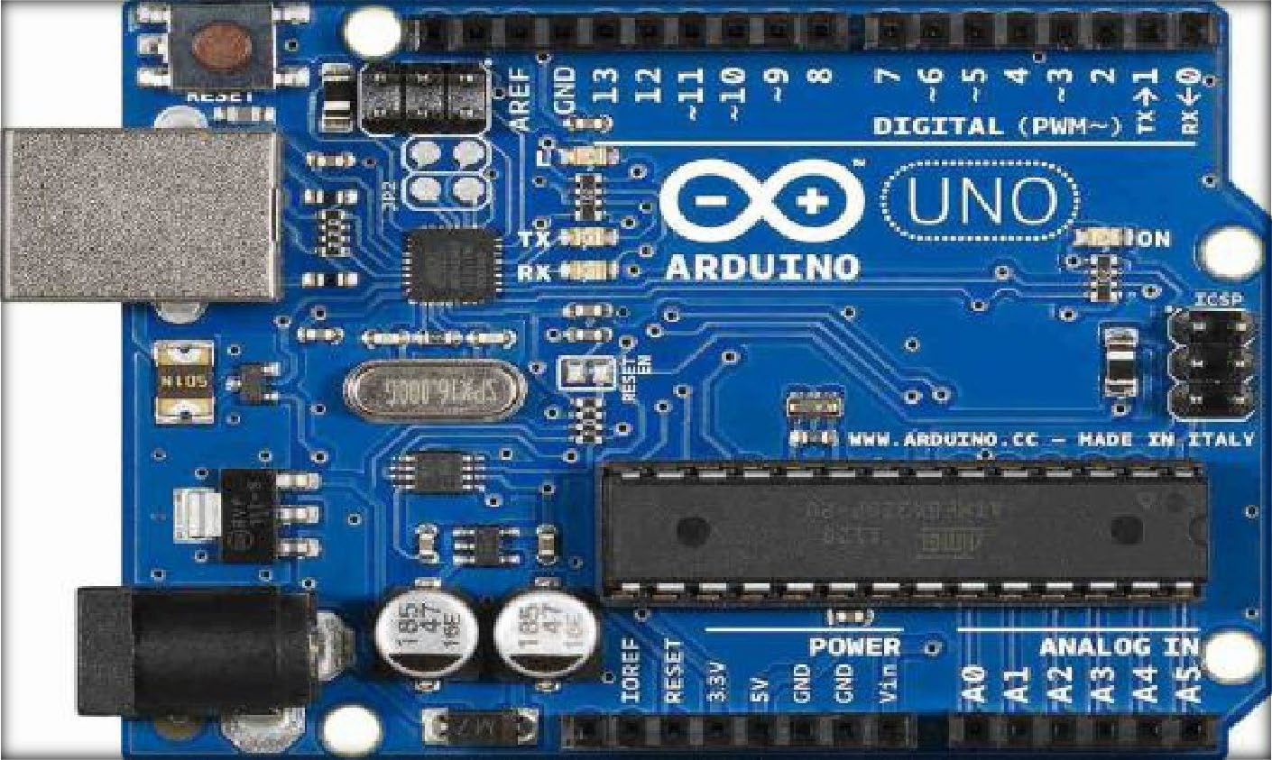

**Fig. 6.4 Arduino R3**

* + 1. **Jumper Wires:** These are conducting wires with almost zero resistance and have a pin or connector at both ends and are called by the name of jumper wires. It is used to make connections between different nodes of breadboard or some components of test circuit without soldering. We have two types of jumper wires, one is female type and second is male type.

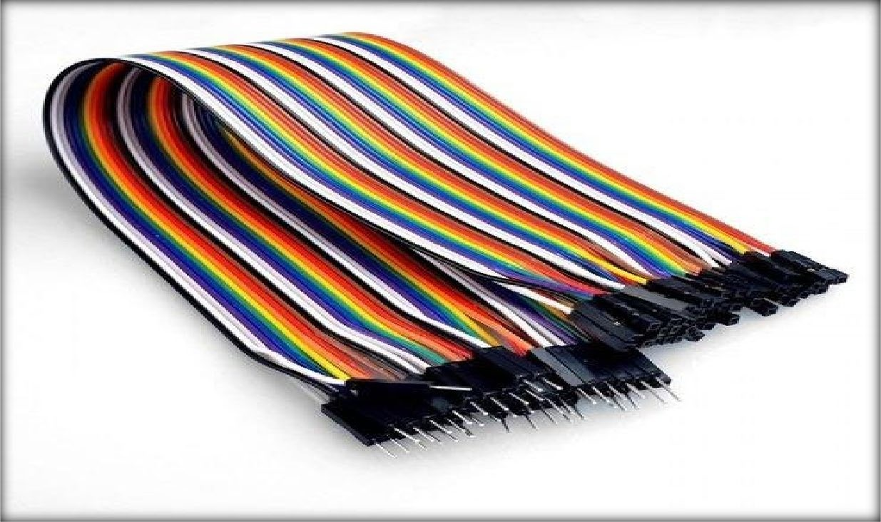

**Fig 6.5 Jumper wires**

* + 1. **Servo motor:** is a motor **(fig. 6.6)** with a Shaft transmission and a gearbox which provides motion with better precision and increased torque. The engine rotates itselfin accordance with the time at which it is pulsed.

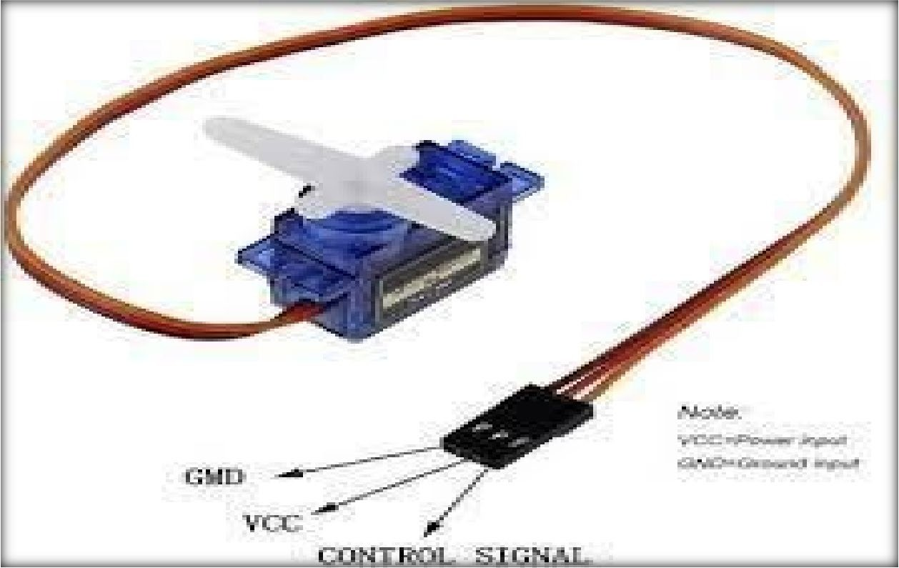

**Fig. 6.6 Servo Motor**

* + 1. **16×2 LCD Display:** It is an electronic display **(fig. 6.7)** that can show up to 32 characters (16 in one line) on a single screen.it uses a variety of Arduino pins for connecting Inter-integrated Circuit(12C). From the data it receives from 12C bus ,it decodes the characters to show on screen.

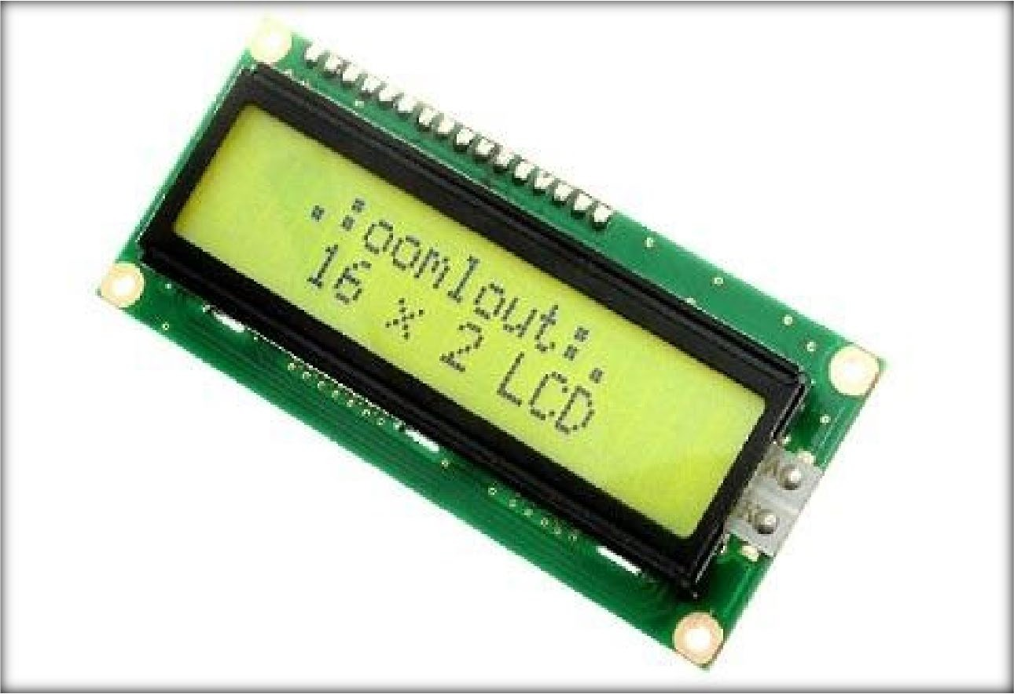

**Fig. 6.7 16x2 LCD**

# REFERENCES

1. Thorat, S. S., M. Ashwini, Akanksha Kelshikar, Sneha Londhe, and Mamta Choudhary. "IoT based smart parking system using rfid." *International Journal of Computer Engineering In Research Trends* 4, no. 1 (2017): 9-12.
2. Pham, Thanh Nam, Ming-Fong Tsai, Duc Binh Nguyen, Chyi-Ren Dow, and Der-Jiunn Deng. "A cloud-based smart-parking system based on Internet-of-Things technologies." *IEEE access* 3 (2015): 1581-1591.
3. Thakre, Mohan P., Payal S. Borse, Nishant P. Matale, and Padmini Sharma. "IOT based smart vehicle parking system using RFID." In *2021 International Conference on Computer Communication and Informatics (ICCCI)*, pp. 1-5. IEEE, 2021.
4. Gandhi, BM Kumar, and M. Kameswara Rao. "A prototype for IoT based car parking management system for smart cities." *Indian Journal of Science and Technology* 9, no. 17 (2016): 1-6.
5. Thangam, E. Cassin, M. Mohan, J. Ganesh, C. V. Sukesh, and A. Prof. "Internet of Things (IoT) based smart parking reservation system using raspberry-pi." *International Journal of Applied Engineering Research* 13, no. 8 (2018): 5759-5765.
6. Agarwal, Yash, Punit Ratnani, Umang Shah, and Puru Jain. "IoT based smart parking system." In *2021 5th International Conference on Intelligent Computing and Control Systems (ICICCS)*, pp. 464-470. IEEE, 2021.
7. Sadhukhan, Pampa. "An IoT-based E-parking system for smart cities." In *2017 International conference on advances in computing, communications and informatics (ICACCI)*, pp. 1062-1066. IEEE, 2017.
8. Tsiropoulou, Eirini Eleni, John S. Baras, Symeon Papavassiliou, and Surbhit Sinha. "RFID- based smart parking management system." *Cyber-Physical Systems* 3, no. 1-4 (2017): 22-41.
9. Cynthia, J., C. Bharathi Priya, and P. A. Gopinath. "IOT based smart parking management system." *Int. J. Recent Technol. Eng.(IJRTE)* 7, no. 4 (2018).
10. Pala, Zeydin, and Nihat Inanc. "Smart parking applications using RFID technology." In

*2007 1st Annual RFID Eurasia*, pp. 1-3. IEEE, 2007.

1. Mudaliar, Shruthi, Shreya Agali, Sujay Mudhol, and C. Jambotkar. "IoT based smart car parking system." *Int J Sci Adv Res Technol* 5, no. 1 (2019): 270-272.
2. Al Taweel, Zainab, Lavanya Challagundla, Alexander Pagan, and Abdel-shakour Abuzneid. "Smart parking for disabled parking improvement using RFID and database authentication." In *2020 IEEE 6th World Forum on Internet of Things (WF-IoT)*, pp. 1-5. IEEE, 2020.
3. Patro, Sibo Prasad, Padmaja Patel, Murali Krishna Senapaty, Neelamadhab Padhy, and Rahul Deo Sah. "IoT based smart parking system: a proposed algorithm and model." In *2020 International Conference on Computer Science, Engineering and Applications (ICCSEA)*, pp. 1-6. IEEE, 2020.
4. Amala, Ch, G. Naga Lakshmi, Ksri Devi, G. Meghana, and G. Thabitha. "Iot based smart parking management system using RFID technology." *International Journal for Recent Developments in Science & Technology* 4, no. 6 (2020): 142-147.
5. Chippalkatti, Pranav, Ganesh Kadam, and Vrushali Ichake. "I-SPARK: IoT based smart parking system." In *2018 international conference on advances in communication and computing technology (ICACCT)*, pp. 473-477. IEEE, 2018.
6. Patil, Minal, Vijay Chakole, and Krushna Chetepawad. "IoT Based Economic Smart Vehicle Parking System." In *2020 3rd International Conference on Intelligent Sustainable Systems (ICISS)*, pp. 1337-1340. IEEE, 2020.
7. Kaur, Harkiran, and Jyoteesh Malhotra. "A review of smart parking system based on internet of things." *International Journal of Intelligent Systems and Applications in Engineering* 6, no. 4 (2018): 248-250.
8. Tripathi, Vinay Raj. "Smart vehicle parking system using IoT." In *2020 International Conference on Electrical and Electronics Engineering (ICE3)*, pp. 285-290. IEEE, 2020.
9. Ramasamy, Manickam, Sunil Govinda Solanki, Elango Natarajan, and Tham Mun Keat. "IoT based smart parking system for large parking lot." In *2018 IEEE 4th International Symposium in Robotics and Manufacturing Automation (ROMA)*, pp. 1-4. IEEE, 2018.
10. Patro, Sibo Prasad, Padmaja Patel, Murali Krishna Senapaty, Neelamadhab Padhy, and Rahul Deo Sah. "IoT based smart parking system: a proposed algorithm and model." In *2020 International Conference on Computer Science, Engineering and Applications (ICCSEA)*, pp. 1-6. IEEE, 2020.
11. Balmiki, Dipali, Manas Singhal, Anupama Singh, and Divyangi Tyagi. "a Research on Smart Vehicle Parking System." *International Journal of Scientific Research and Management Studies* 4, no. 7 (2020): 124-127.
12. Tsiropoulou, Eirini Eleni, John S. Baras, Symeon Papavassiliou, and Surbhit Sinha. "RFID-based smart parking management system." *Cyber-Physical Systems* 3, no. 1-4 (2017): 22-41.
13. Atiqur, Rahman, and Yun Li. "Automated smart car parking system using raspberry Pi 4 and iOS application." *International Journal of Reconfigurable and Embeded Systems (IJRES)* 9, no. 3 (2020): 229-234.
14. Hainalkar, Gayatri N., and Mousami S. Vanjale. "Smart parking system with pre & post reservation, billing and traffic app." In *2017 International Conference on Intelligent Computing and Control Systems (ICICCS)*, pp. 500-505. IEEE, 2017.